**ASSIGNMENT**

**PROGRAMMING IN JAVA FOR GAMING**

**(CSA0988)**

**EASY PROGRAMS - 20**

**MEDIUM PROGRAMS - 20**

**HARD PROGRAMS – 10**

**NAME:K.SHANMUKHA PRIYA**

**REG NO:192011233**

**SLOT – C**

**EASY PROGRAMS (20)**

1.Write a program to print the below pattern

1

2 2

3 3 3

4 4 4 4

3 3 3

2 2

1

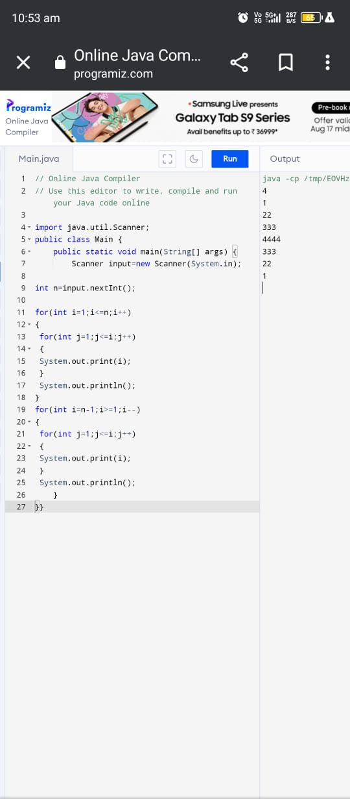

2.Write a program to print hollow Square Dollar pattern?

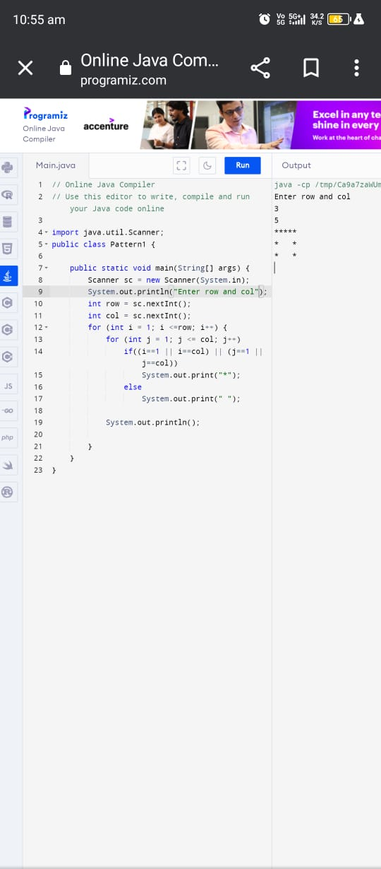

3.Write a program to print inverted pyramid pattern.

Input: no of rows: 3

Output

*****

***

*

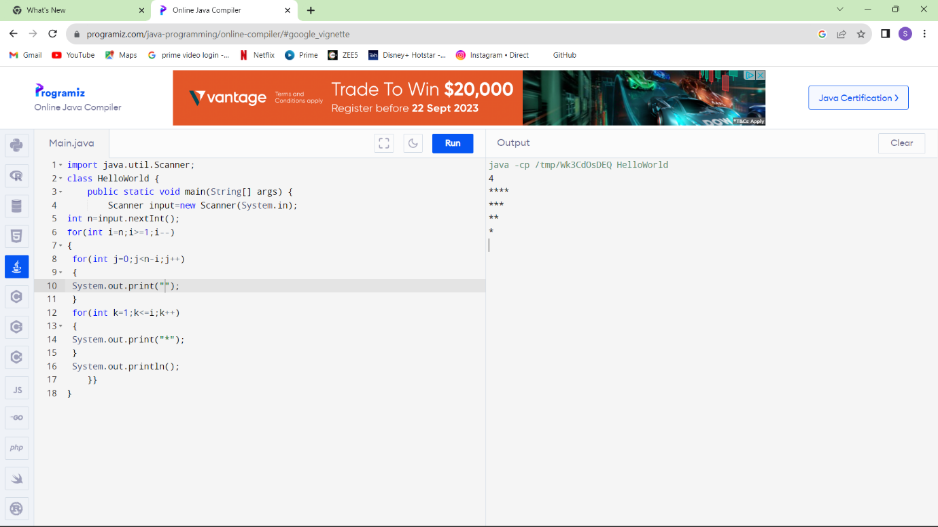

**General:**

4.Write a program to reverse a number using loop?(Get the input from user)

Sample Input:

Number: 14567

Sample Output:

Reverse Number: 76541

Test cases:

1. -45721
2. 000
3. AD1947
4. !@#$%
5. 145*999=144855

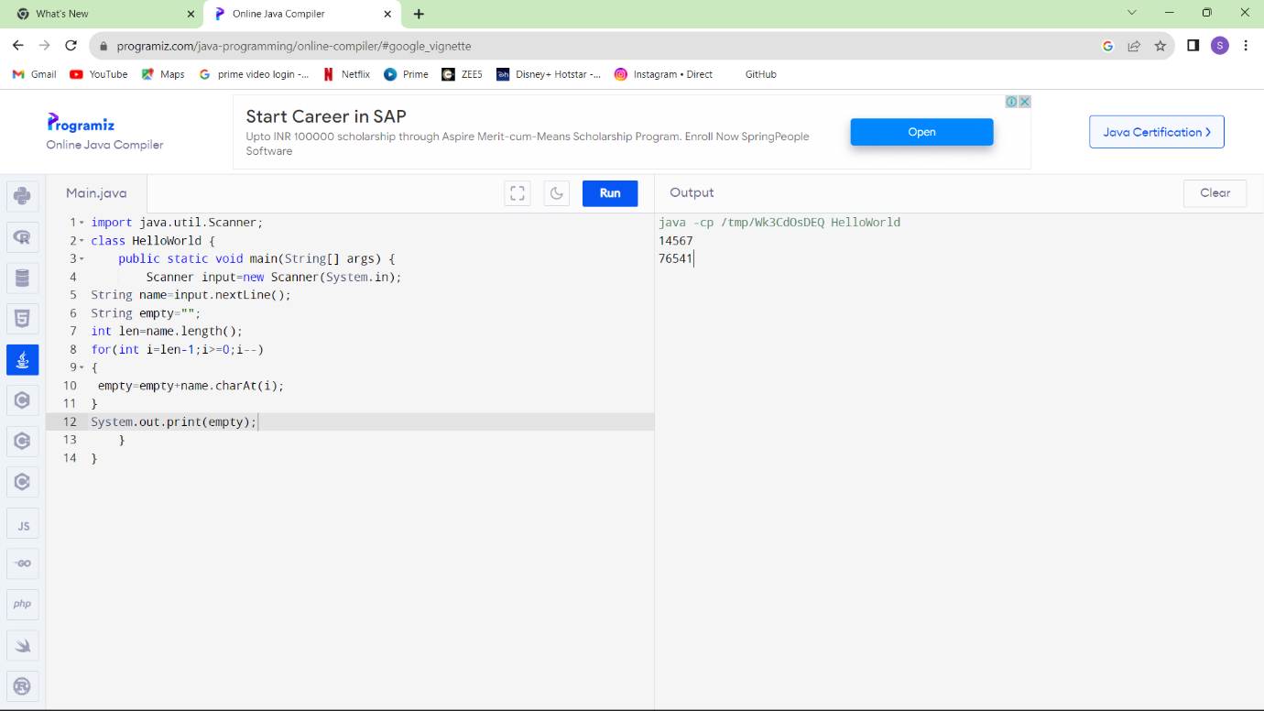

5.Write a program to find whether the person is eligible for vote or not. And if that particular person is not eligible, then print how many years are left to be eligible.

Sample Input:

Enter your age: 7

Sample output:

You are allowed to vote after 11 years

Test cases:

1. 25
2. Eighteen
3. 12
4. -18
5. 34.5

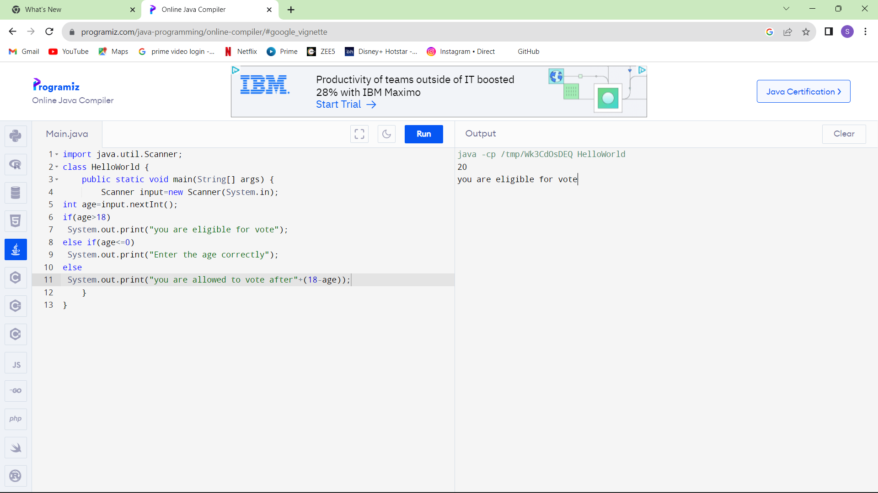

6.Find the LCM and GCD of n numbers?

Sample Input:

N value = 2

Number 1 = 16

Number 2 = 20

Sample Output:

LCM = 80

GCD = 4

Test cases:

1. N = 3, {12, 25, 30}
2. N = 2, {52, 25, 63}
3. N = 3, {17, 19, 11}
4. N = -2, {52, 60}
5. N = 2, {30, 45}

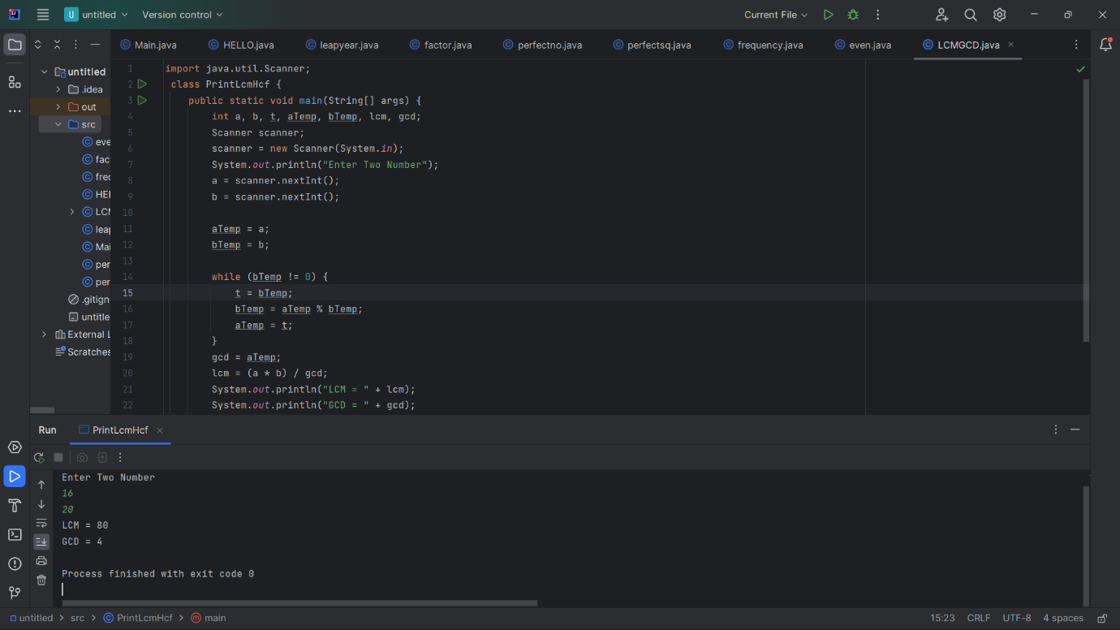

7.Write a program using function to calculate the simple interest. Suppose the customer is a senior citizen. He is being offered 12 percent rate of interest; for all other customers, the ROI is 10 percent.

Sample Input:

Enter the principal amount: 200000

Enter the no of years: 3

Is customer senior citizen (y/n): n

Sample Output:

Interest: 60000

Test Cases:

1. Principal: 2000 , Years: 0
2. Principal: 20000 , Years: -2
3. Principal: -2000 , Years: 2
4. Principal: 2 , Years: 2000
5. Principal: 0 , Years: 5

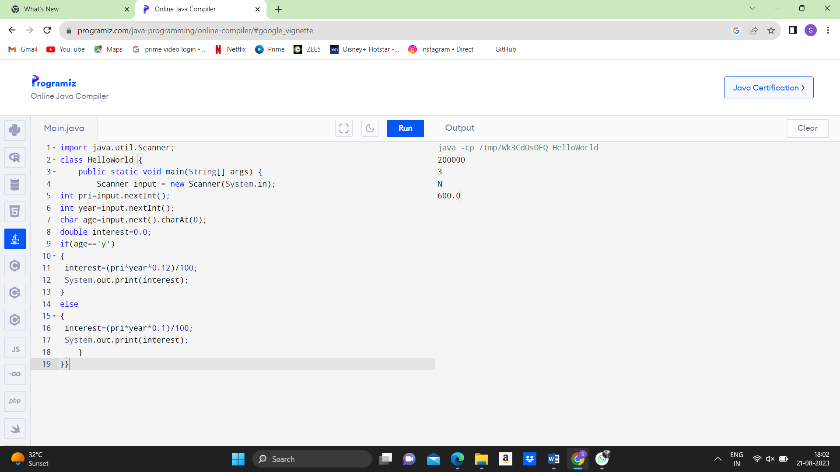

8.Write a program to print the Fibonacci series.

Sample Input:

Enter the n value: 6

**Sample Output:**

0 1 1 2 3 5

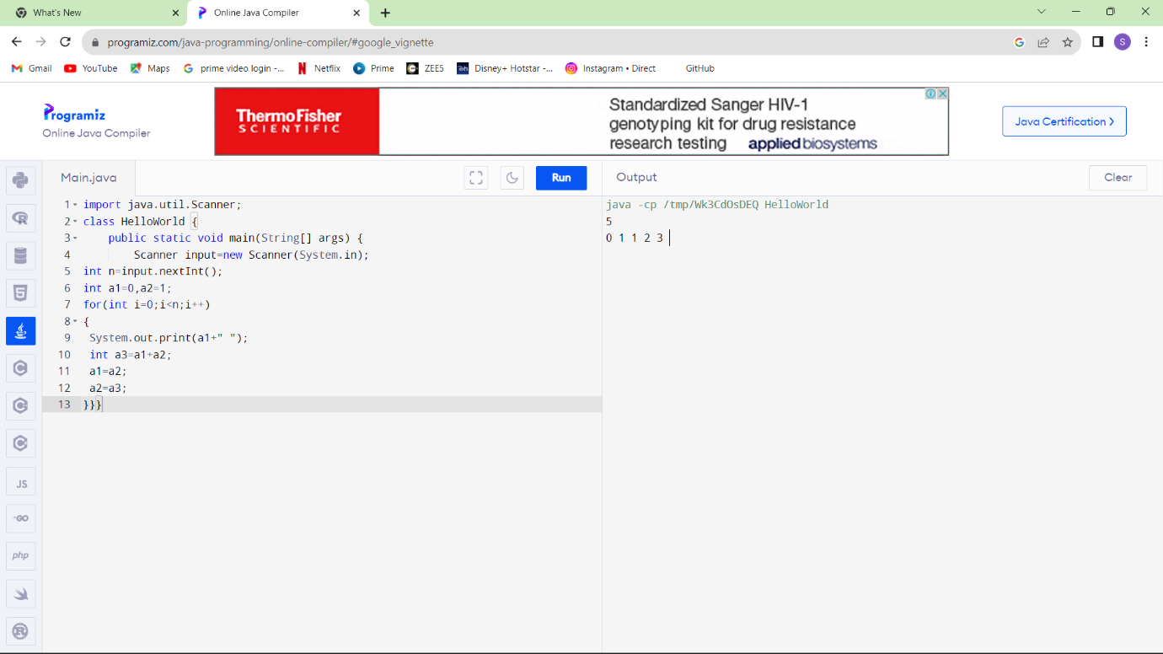

9 .[Java Program to Find Even Sum of Fibonacci Series Till number N](https://www.geeksforgeeks.org/java-program-to-find-sum-of-fibonacci-series-numbers-of-first-n-even-indexes/)?

Sample Input: n = 4

Sample Output: 33

(N = 4, So here the fibonacci series will be produced from 0th term till 8th term:0, 1, 1, 2, 3, 5, 8, 13, 21

Sum of numbers at even indexes = 0 + 1 + 3 + 8 + 21 = 33)

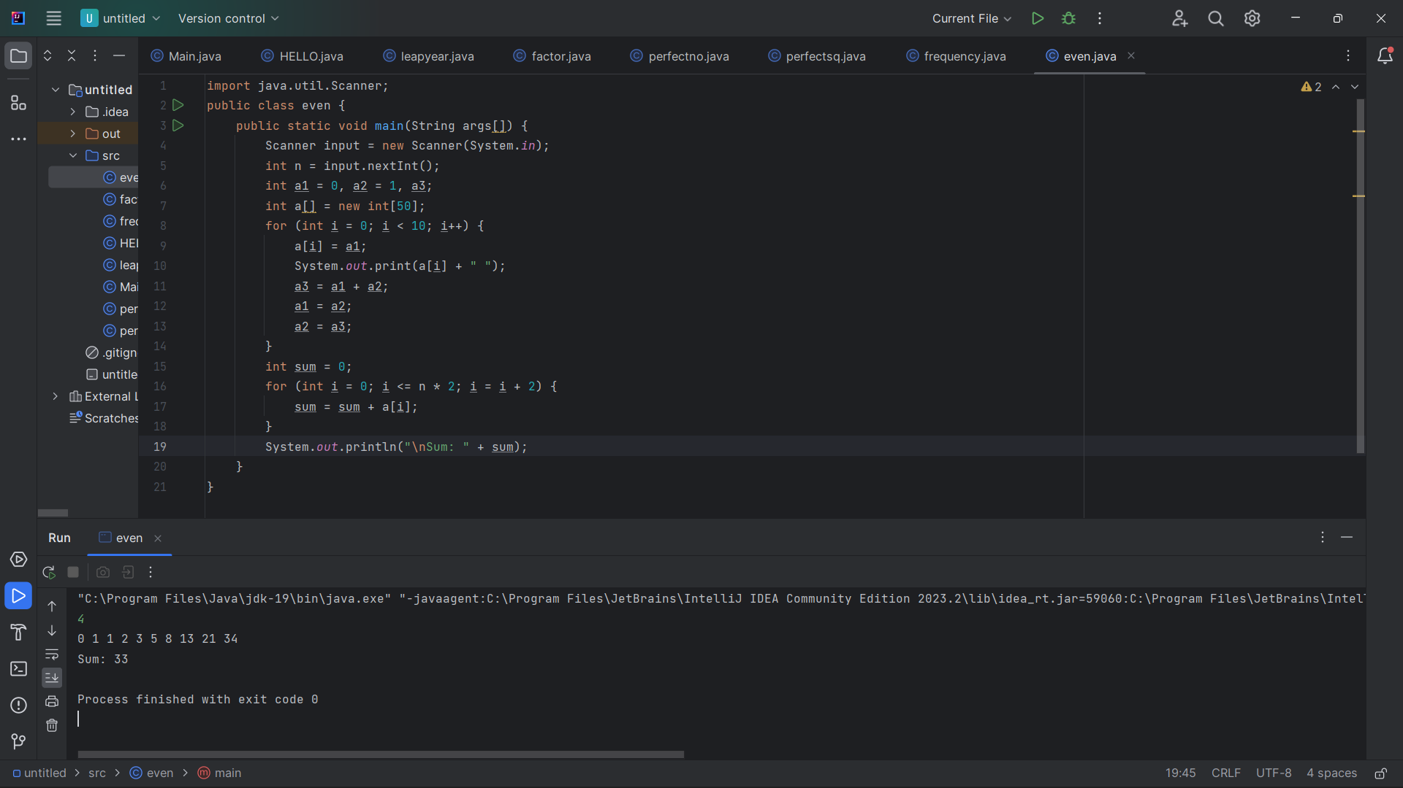

10.Write a program to print the numbers from M to N by skipping K numbers in between?

Sample Input:

M = 50

N = 100

K = 7

Sample Output:

50, 58, 66, 74, …..

Test cases:

1. M = 15, N = 05, K = 02
2. .M = 25, N = 50, K = 04
3. M = 15, N = 100, K = -02
4. M = 0 , N = 0 , K = 2
5. M = 200 , N = 200 , K = 50

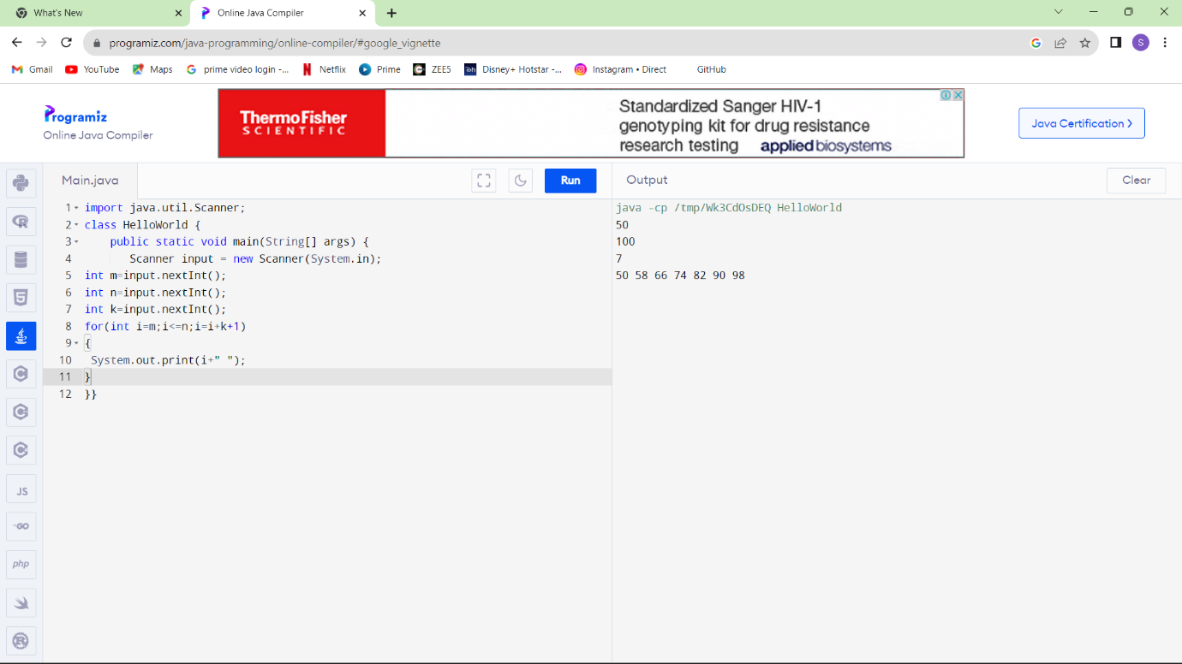

11.Write a program to print all the composite numbers between a and b?

Sample Input:

A = 12

B = 19

Sample Output

14, 15, 16, 18

Test cases:

1. A = 11, B = 11
2. A = 20, B = 10
3. A = 0, B = 0
4. A = -5, B = 5
5. A = 7, B = -12

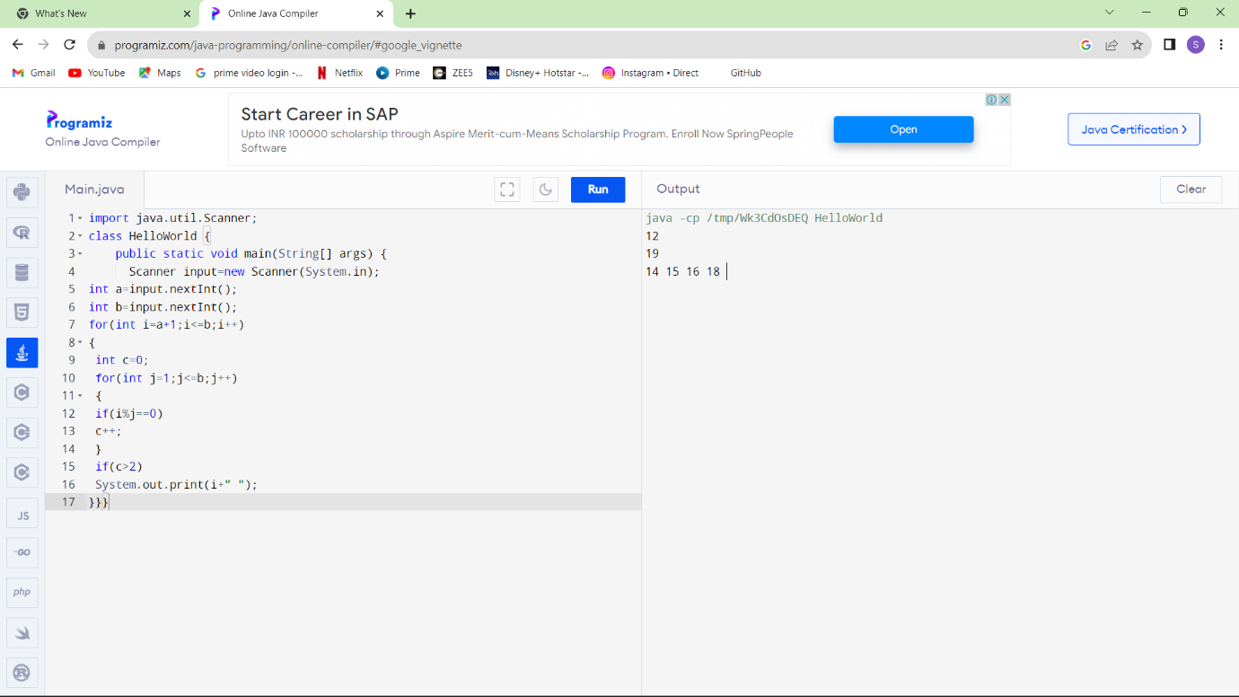

12.Find the factorial of n?

Sample Input:

N = 4

Sample Output:

4 Factorial = 24

Test cases:

1. N = 0
2. N = -5
3. N = 1
4. N = Q
5. N = 3A

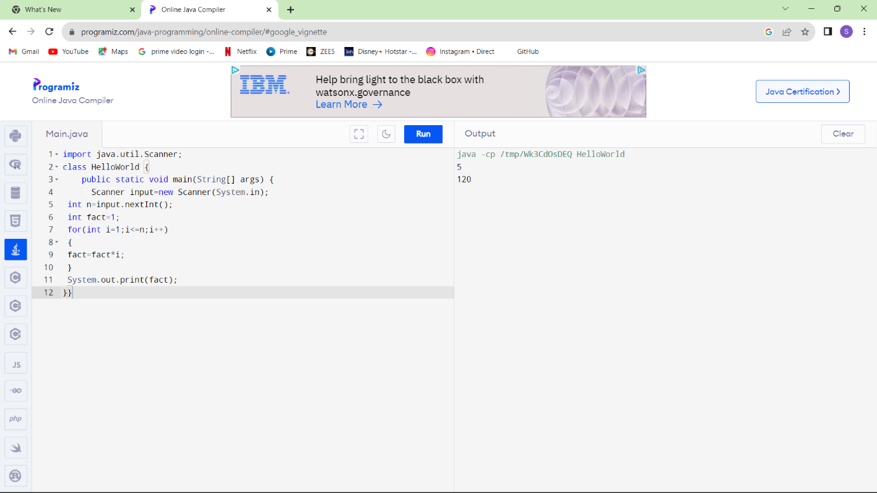

13.Find the year of the given date is leap year or not

Sample Input:

Enter Date: 04/11/1947

Sample Output:

Given year is Non Leap Year

Test cases:

1. 04/11/19.47
2. 11/15/1936
3. 31/45/1996
4. 64/09/1947
5. 00/00/2000

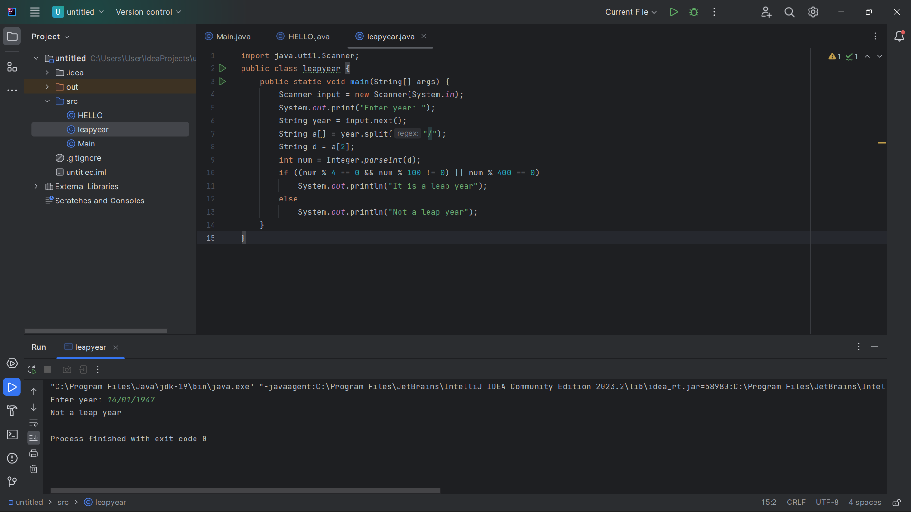

14.Find the number of factors for the given number

Sample Input:

Given number: 100

Sample Output:

Number of factors = 9

Test cases:

1. 343
2. 1080
3. -243
4. 101010
5. 0

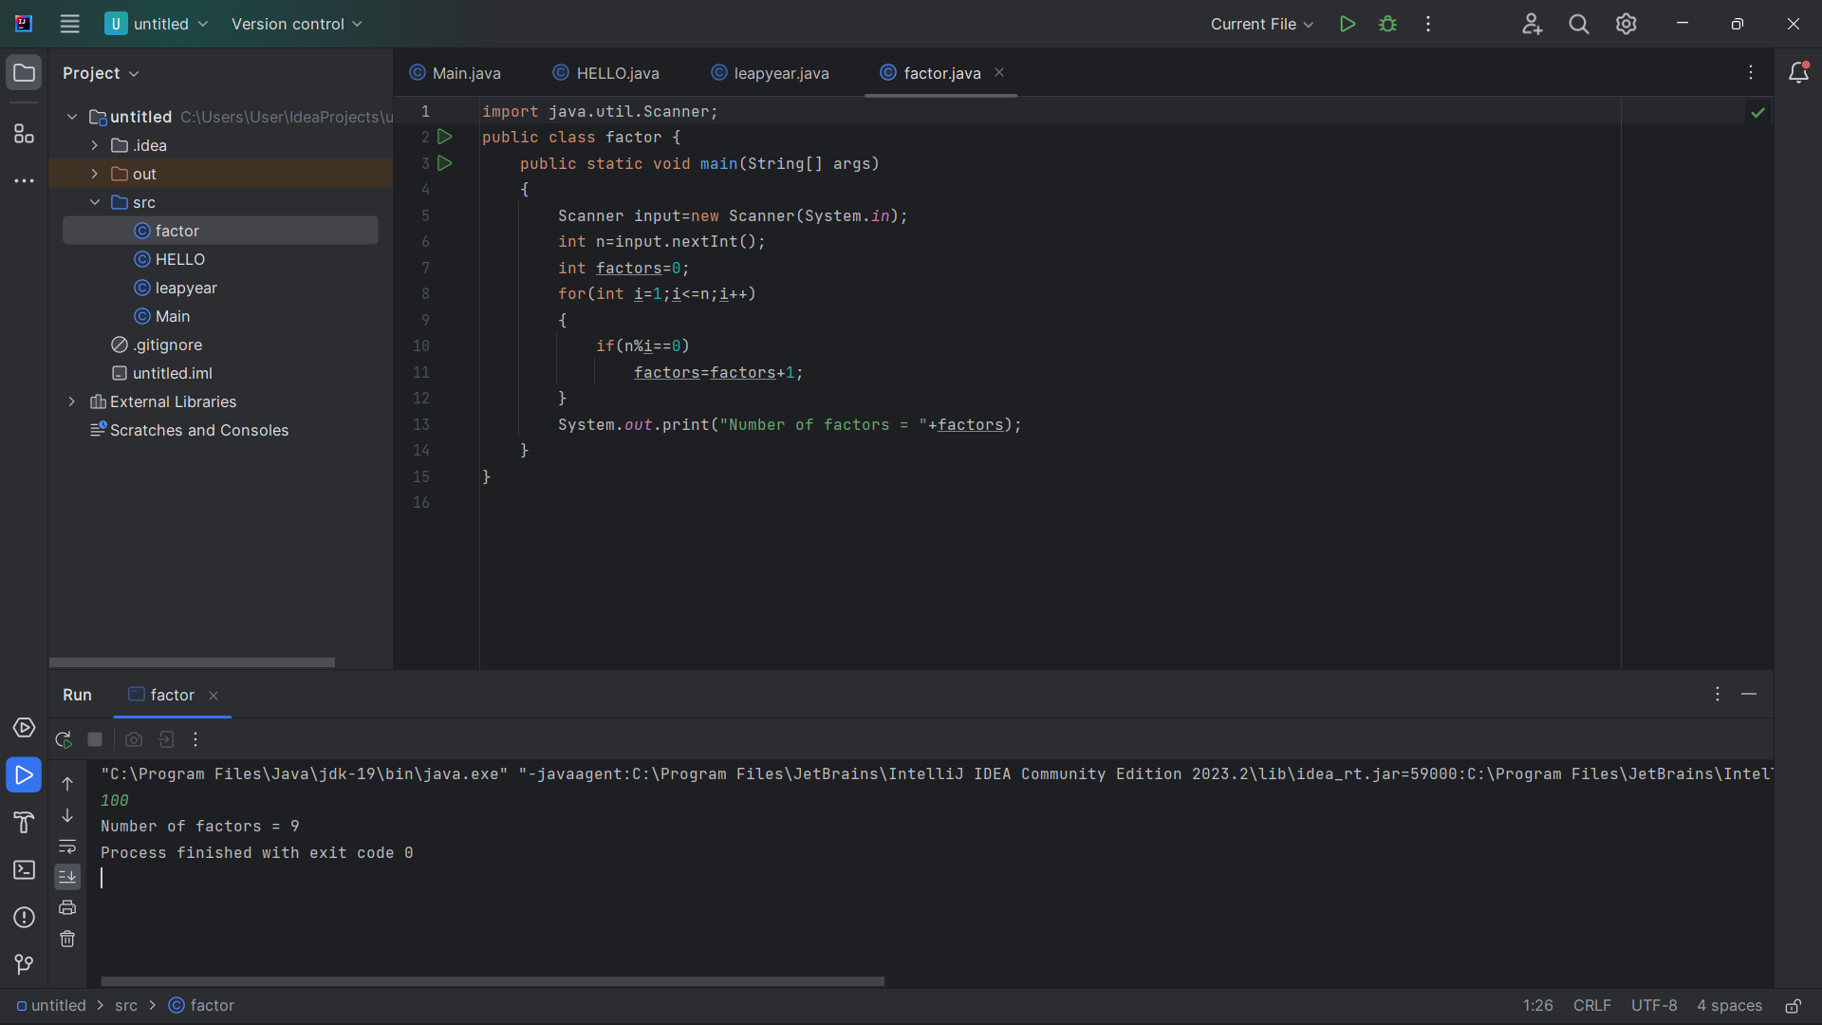

15.Write a program to print the given number is Perfect number or not?

Sample Input:

Given Number: 6

Sample Output:

It’s a Perfect Number

Test cases:

1. 17
2. 26!
3. 143
4. 84.1
5. -963

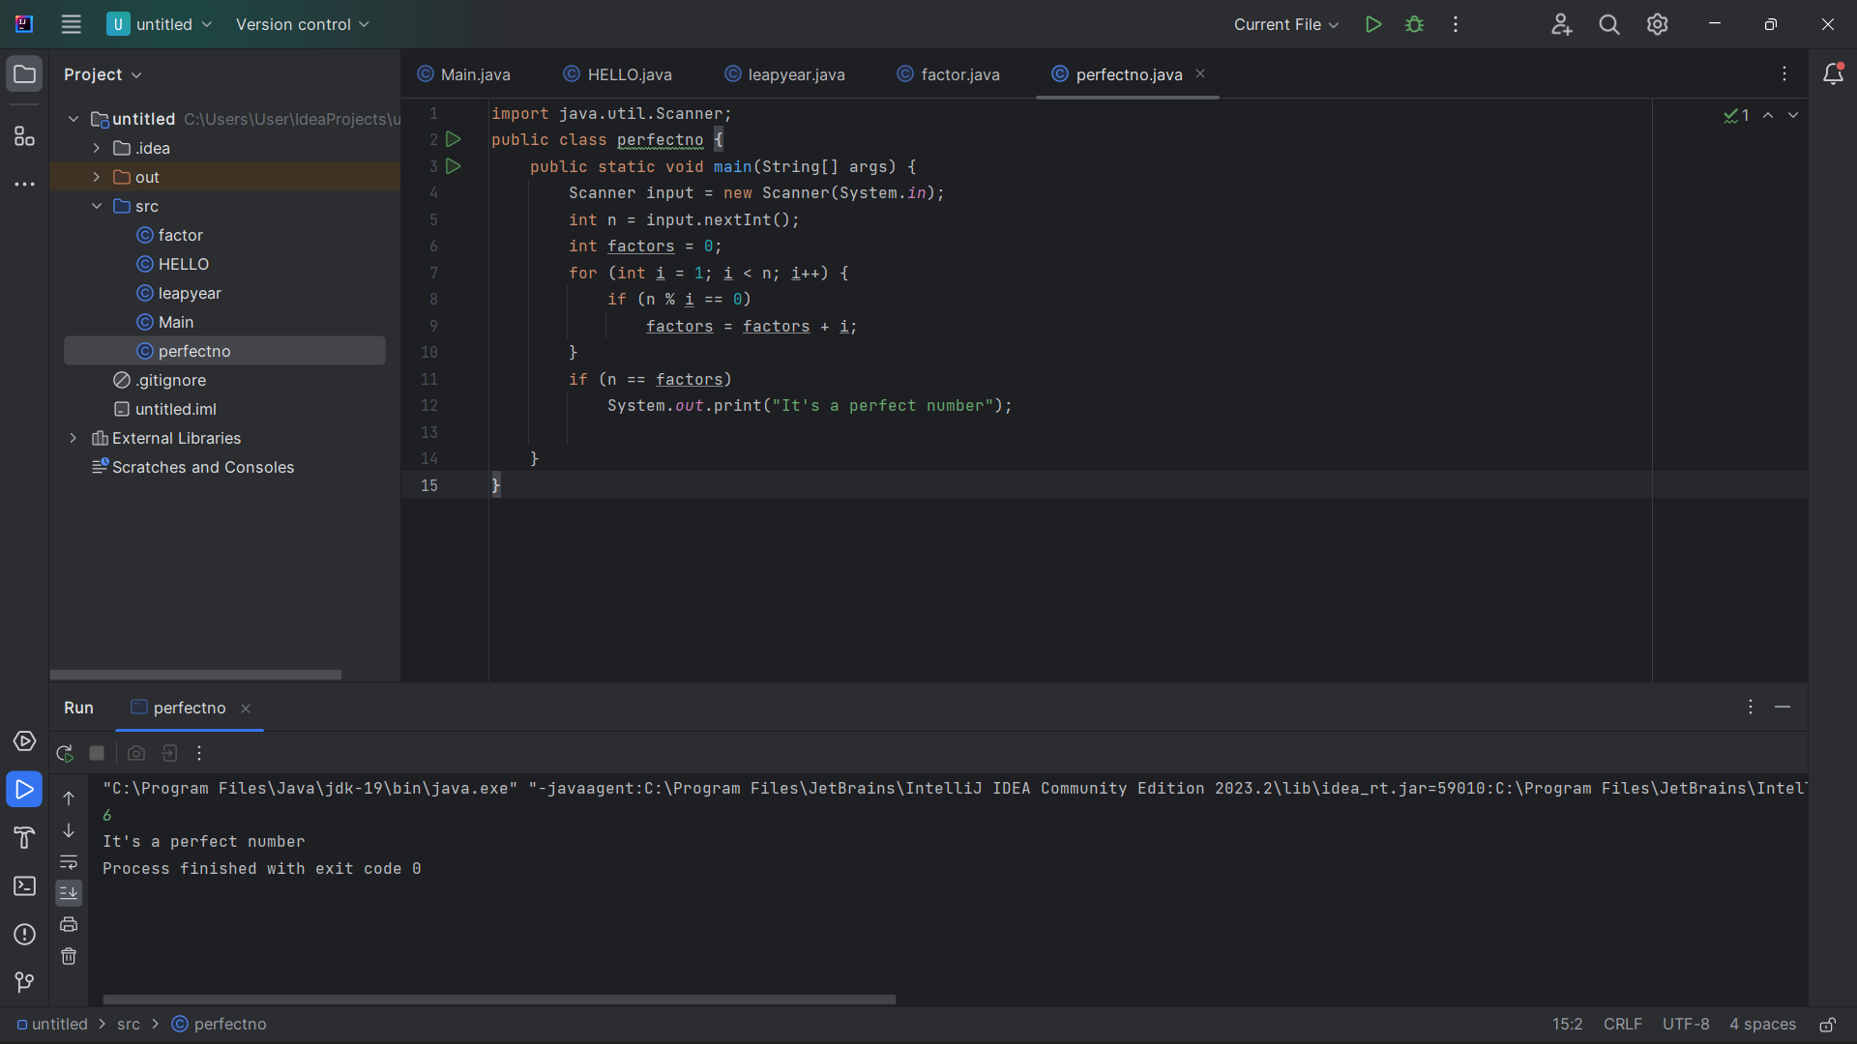

16.Write a program to find the square, cube of the given decimal number

Sample Input:

Given Number: 0.6

Sample Output:

Square Number: 0.36

Cube Number:0.216

Test cases:

1. 12
2. 0
3. -0.5
4. 14.25
5. -296

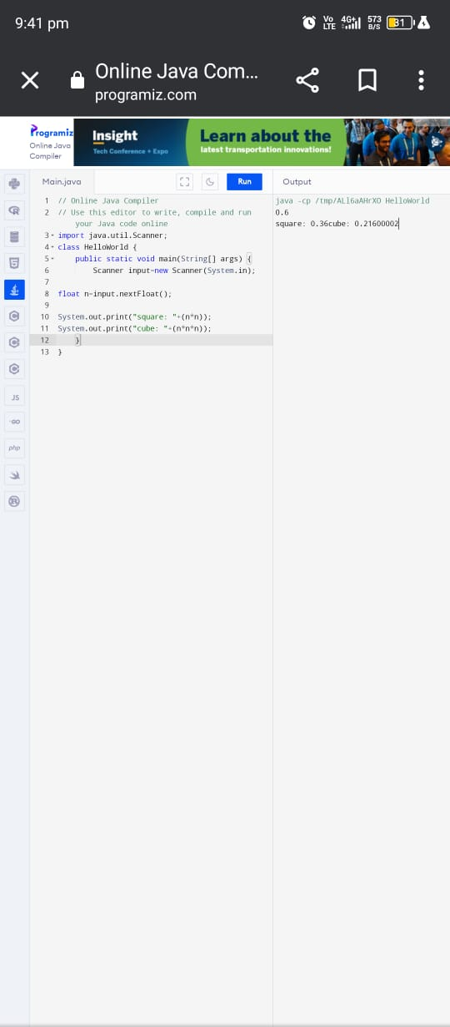

17.Find the nth odd number after n odd number

Sample Input: N : 7

Sample Output:

Hence the values printed for i are 1 , 3 , 5.

Test cases:

1. N = 0
2. N = -6
3. N = 2021
4. N = -14.5
5. N = -196

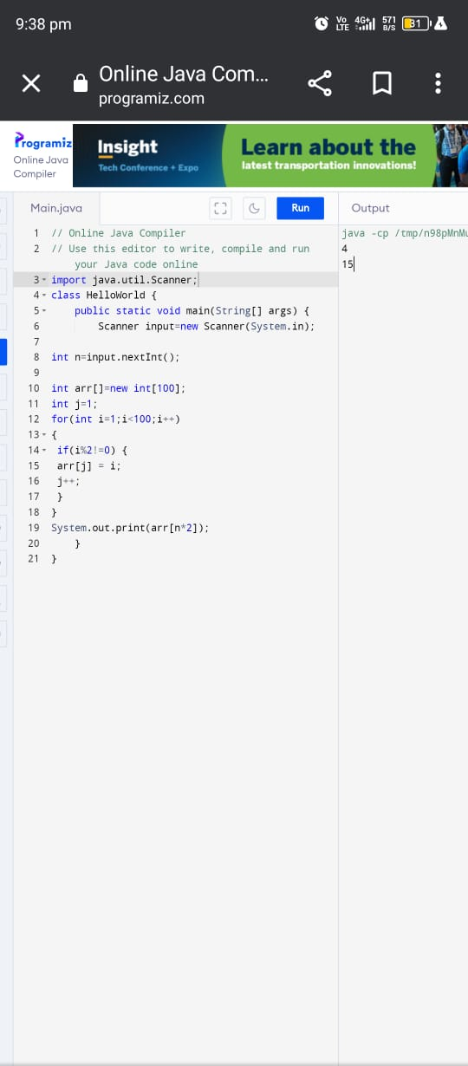

18.Program to find the frequency of each element in the array.

Sample Input & Output:

{1, 2, 8, 3, 2, 2, 2, 5, 1}

**Pseudo**:

Element | Frequency

--------------------------

1 | 2

2 | 4

8 | 1

3 | 1

4 | 1

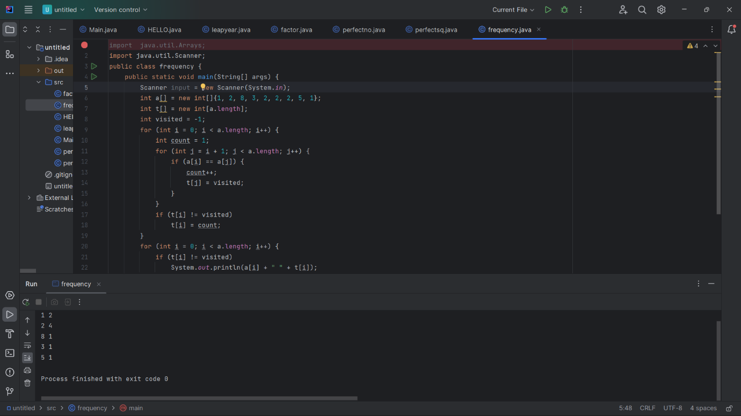

19.Program to find whether the given number is Armstrong number or not

Sample Input:

Enter number: 153

Sample Output:

Given number is Armstrong number

Test cases:

1. 370
2. 1
3. 371
4. 145678
5. 0.21345

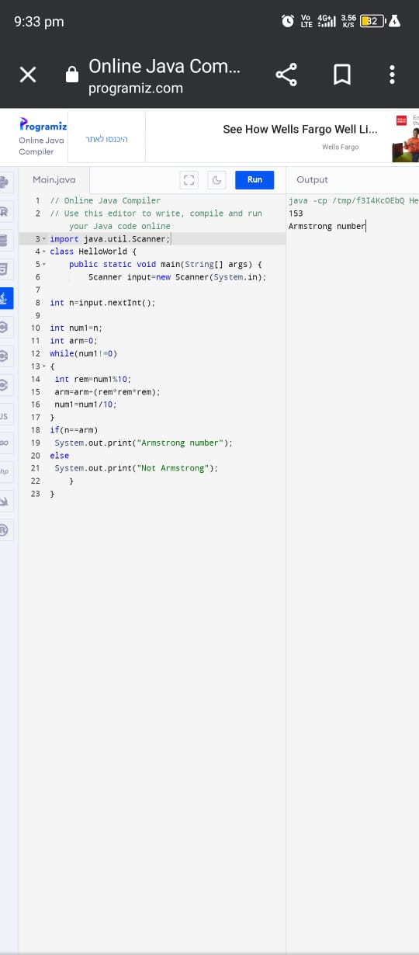

20.Write a program to find the sum of digits of N digit number (sum should be single digit)

Sample Input:

Enter N value: 3

Enter 3 digit numbers: 143

Test cases:

1. N = 2, 158
2. N = 3, 14
3. N = 4, 0148
4. N = 1, 0004
5. N = 4, 7263

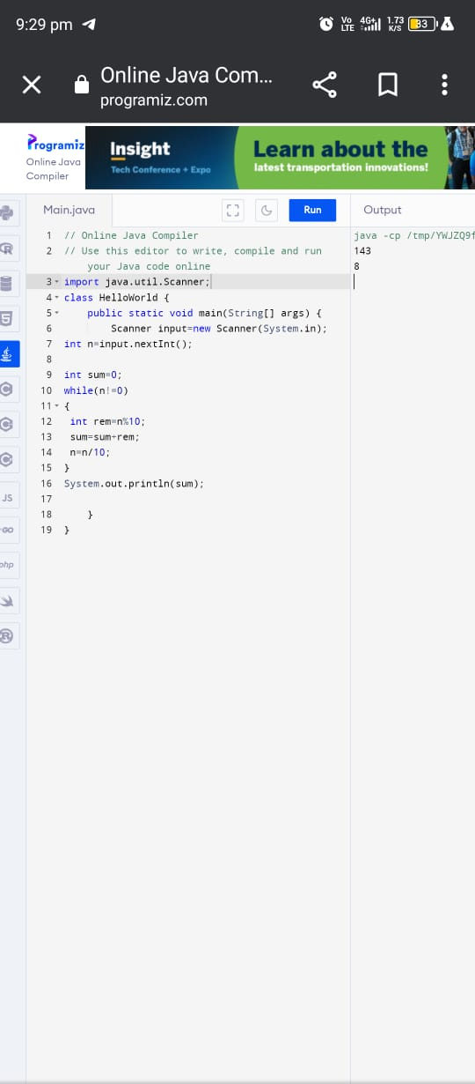

**MEDIUM PROGRAMS (20)**

1. Write a program to count all the prime and composite numbers entered by the user.

Sample Input:

Enter the numbers

4

54

29

71

7

59

98

23

Sample Output:

Composite number:3

Prime number:5

Test cases:

1. 33, 41, 52, 61,73,90
2. TEN, FIFTY, SIXTY-ONE, SEVENTY-SEVEN, NINE
3. 45, 87, 09, 5.0 ,2.3, 0.4
4. -54, -76, -97, -23, -33, -98
5. 45, 73, 00, 50, 67, 44

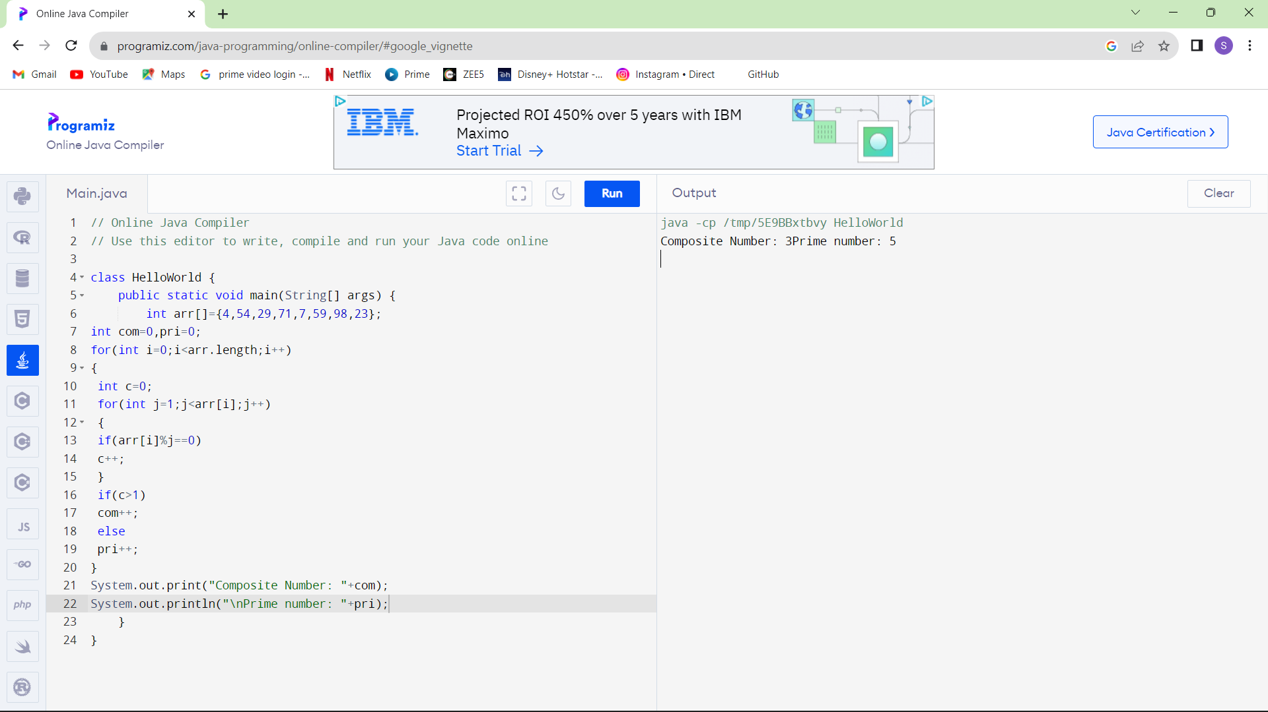

1. Find the Mth maximum number and Nth minimum number in an array and then find the sum of it and difference of it.

Sample Input:

Array of elements = {14, 16, 87, 36, 25, 89, 34}

M = 1

N = 3

Sample Output:

1stMaximum Number = 89

3rdMinimum Number = 25

Sum = 114

Difference = 64

Test cases:

1. {16, 16, 16 16, 16}, M = 0, N = 1
2. {0, 0, 0, 0}, M = 1, N = 2
3. {-12, -78, -35, -42, -85}, M = 3 , N = 3
4. {15, 19, 34, 56, 12}, M = 6 , N = 3
5. {85, 45, 65, 75, 95}, M = 5 , N = 7

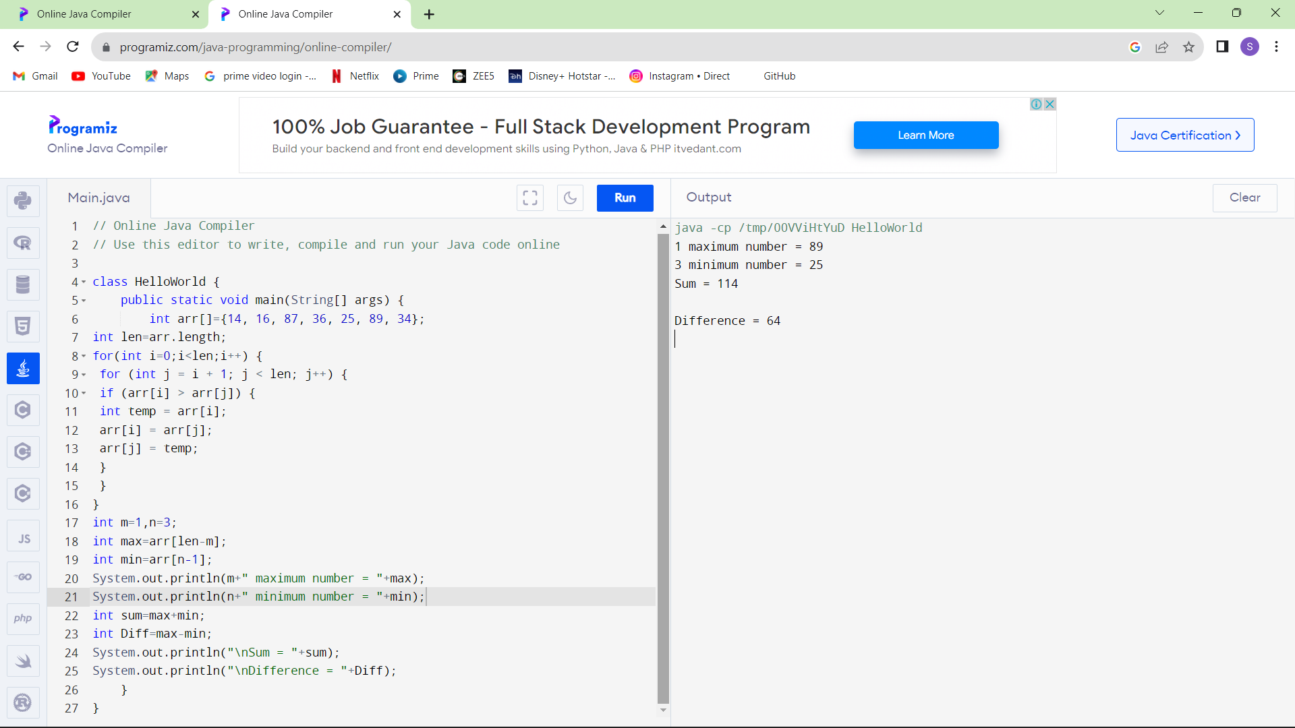

1. Write a program to print the total amount available in the ATM machine with the conditions applied.

Total denominations are 2000, 500, 200, 100, get the denomination priority from the user and the total number of notes from the user to display the total available balance to the user

Sample Input:

Enter the 1st Denomination: 500

Enter the 1st Denomination number of notes: 4

Enter the 2nd Denomination: 100

Enter the 2nd Denomination number of notes: 20

Enter the 3rd Denomination: 200

Enter the 3rd Denomination number of notes: 32

Enter the 4th Denomination: 2000

Enter the 4th Denomination number of notes: 1

Sample Output:

Total Available Balance in ATM: 12400

Test Cases:

3 Hidden Test cases (Think Accordingly based on Denominations)

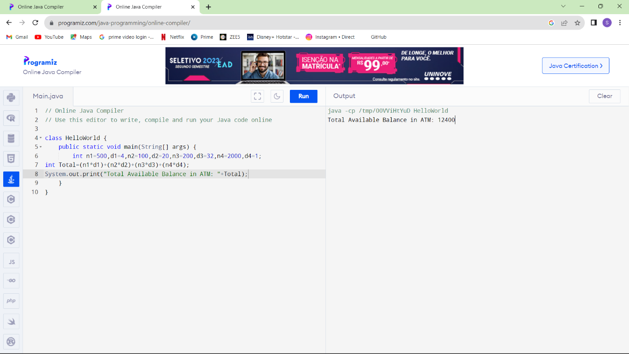

1. Write a program using choice to check

Case 1: Given string is palindrome or not

Case 2: Given number is palindrome or not

Sample Input:

Case = 1

String = MADAM

Sample Output:

Palindrome

Test cases:

1. MONEY
2. 5678765
3. MALAY12321ALAM
4. MALAYALAM
5. 1234.4321

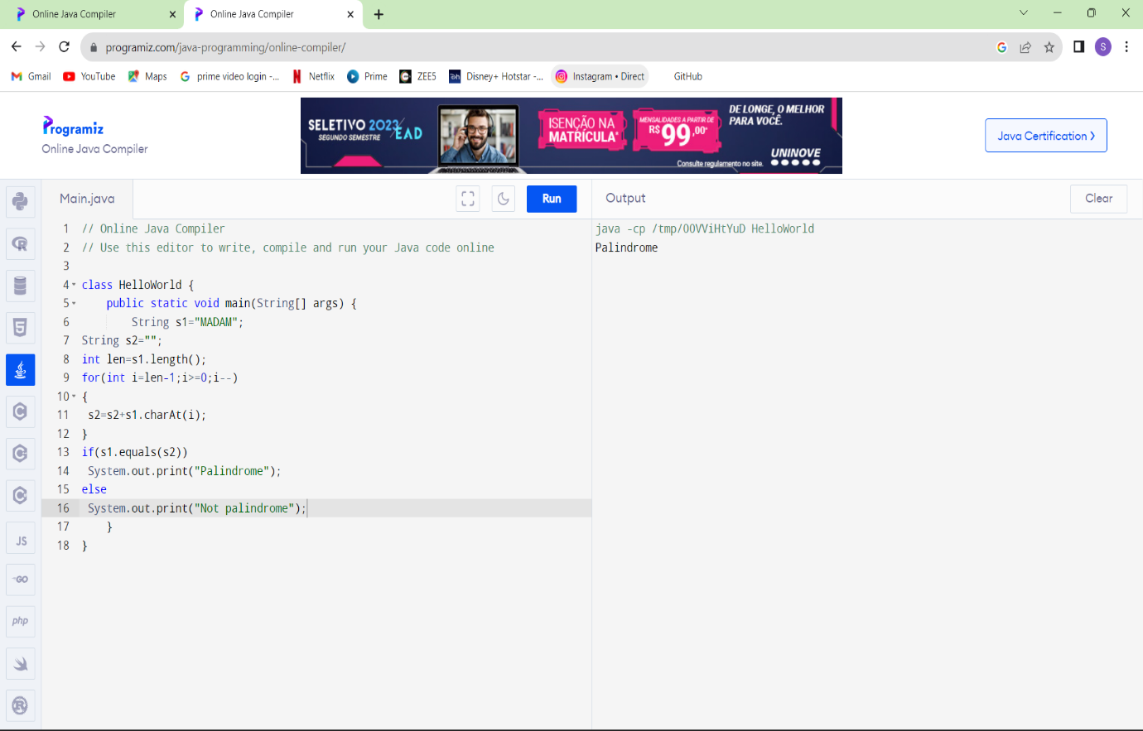

5 Write a program to convert Decimal number equivalent to Binary number and octal numbers?

Sample Input:

Decimal Number: 15

Sample Output:

Binary Number = 1111

Octal = 17

Test cases:

1. 111
2. 15.2
3. 0
4. B12
5. 1A.2

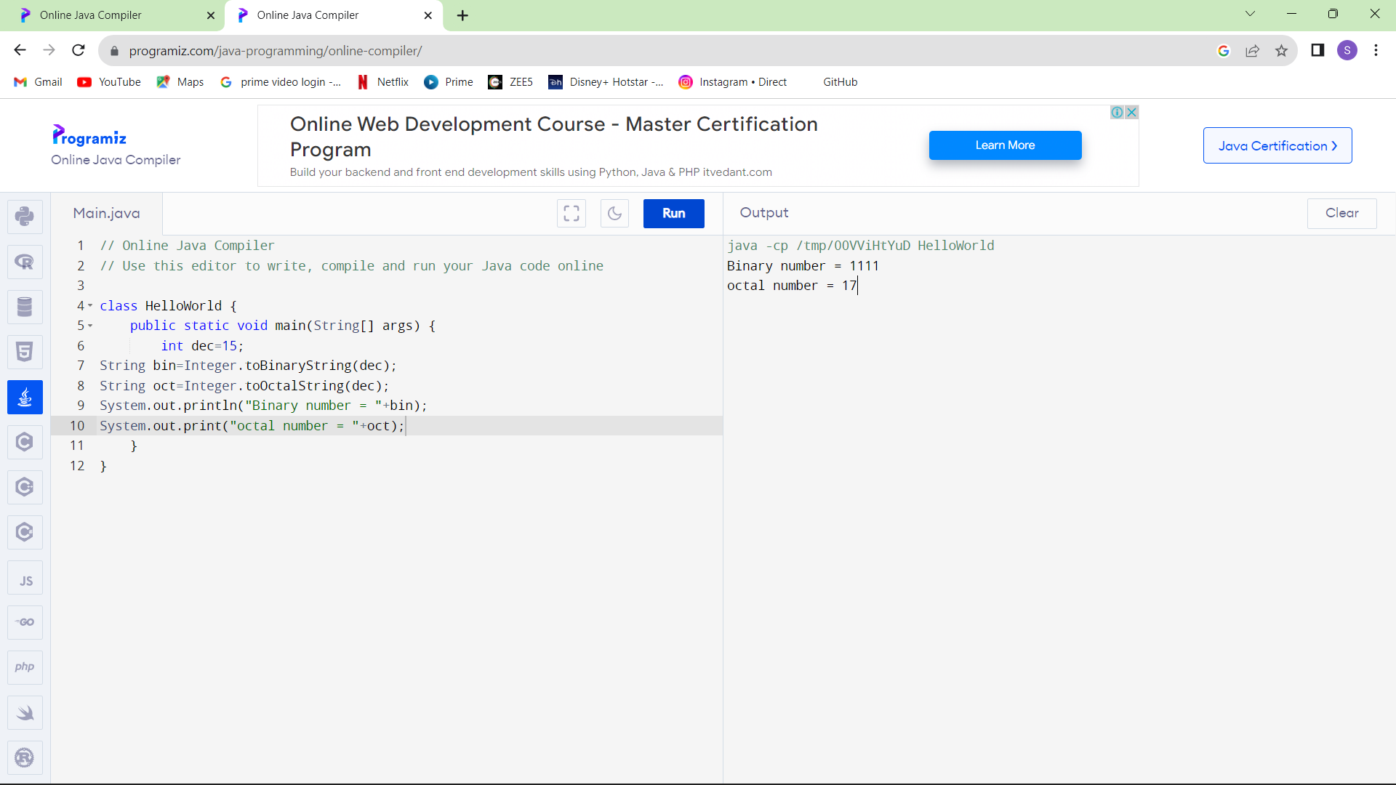

6 . In an organization they decide to give bonus to all the employees on New Year. A 5% bonus on salary is given to the grade A workers and 10% bonus on salary to the grade B workers. Write a program to enter the salary and grade of the employee. If the salary of the employee is less than $10,000 then the employee gets an extra 2% bonus on salary Calculate the bonus that has to be given to the employee and print the salary that the employee will get.

Sample Input & Output:

Enter the grade of the employee: B

Enter the employee salary: 50000

Salary=50000

Bonus=5000.0

Total to be paid:55000.0

Test cases:

1. Enter the grade of the employee: A

Enter the employee salary: 8000

1. Enter the grade of the employee: C

Enter the employee salary: 60000

1. Enter the grade of the employee: B

Enter the employee salary: 0

1. Enter the grade of the employee: 38000

Enter the employee salary: A

1. Enter the grade of the employee: B

Enter the employee salary: -8000

Program

// Online Java Compiler

// Use this editor to write, compile and run your Java code online

import java.util.Scanner;

class HelloWorld {

public static void main(String[] args) {

Scanner input=new Scanner(System.in);

int a,b;

double bonus=0;

System.out.print("Enter the grade of the employee :");

char a1=input.next().charAt(0);

System.out.print("Enter the salary of employee :");

int b1=input.nextInt();

if(a1=='A')

{

bonus=b1*(0.05);

if(b1<10000)

{

bonus=bonus+b1*(0.02);

}

System.out.println("salary = "+b1);

System.out.println("bonus = "+bonus);

System.out.println("total to be paid ="+(b1+bonus));

}

else if(a1=='B')

{

bonus=b1*(0.1);

if(b1<10000)

{

bonus=bonus+b1*(0.02);

}

System.out.println("salary = "+b1);

System.out.println("bonus = "+bonus);

System.out.println("total to be paid ="+(b1+bonus));

}

else {

System.out.print("Enter valid grade");

}

}

}

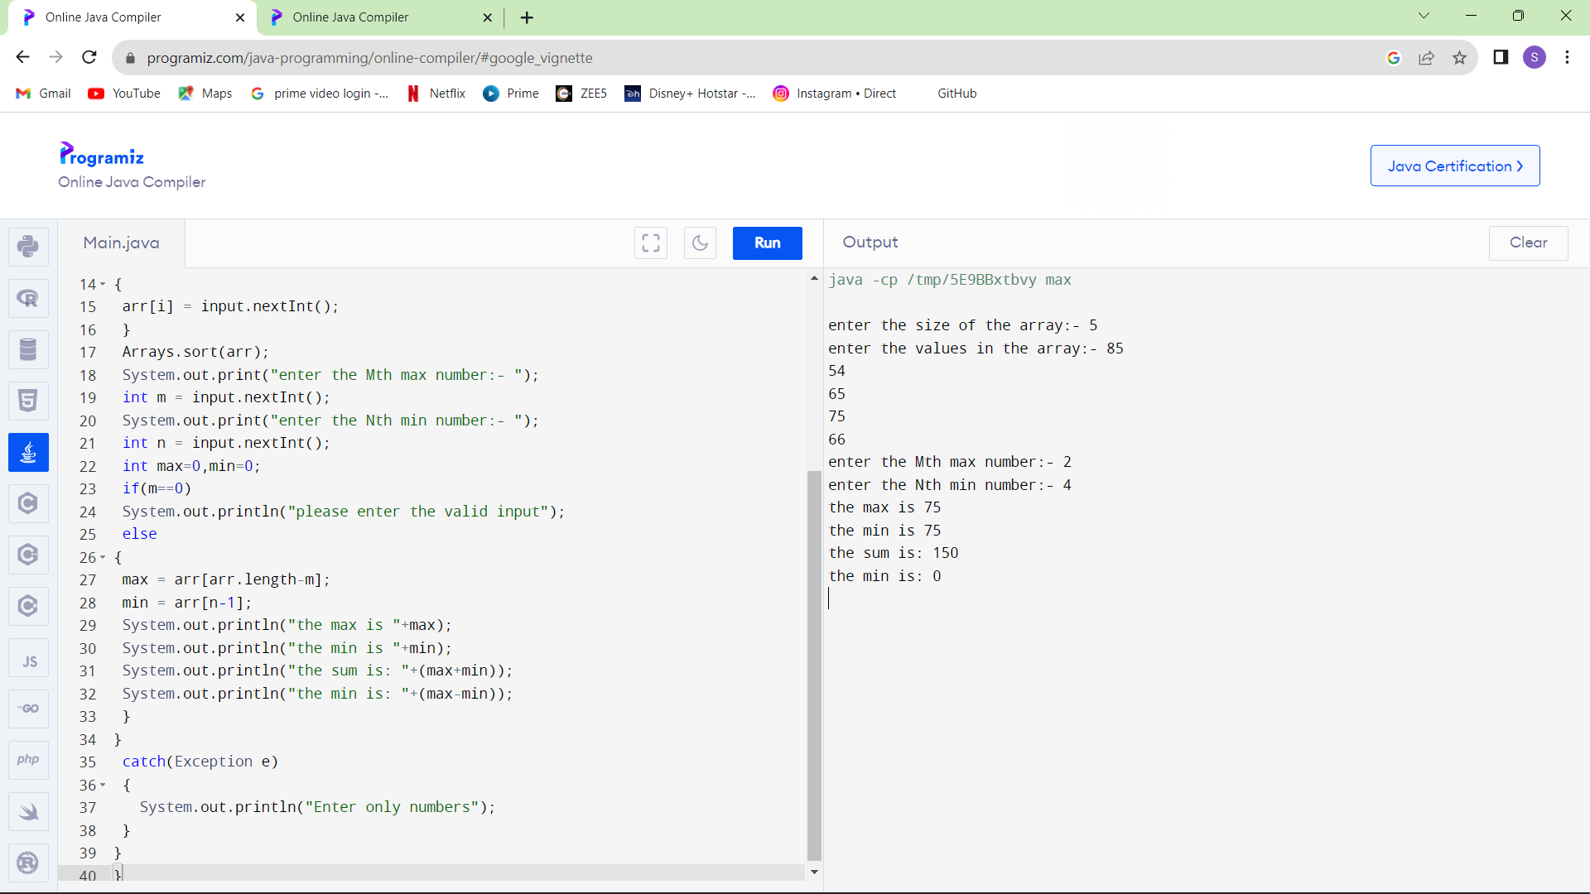

7.Write a program to print the first n perfect numbers. (Hint Perfect number means **a positive integer that is equal to the sum of its proper divisors)**

Sample Input:

N = 3

Sample Output:

First 3 perfect numbers are: 6 , 28 , 496

Test Cases:

1. N = 0
2. N = 5
3. N = -2
4. N = -5
5. N = 0.2

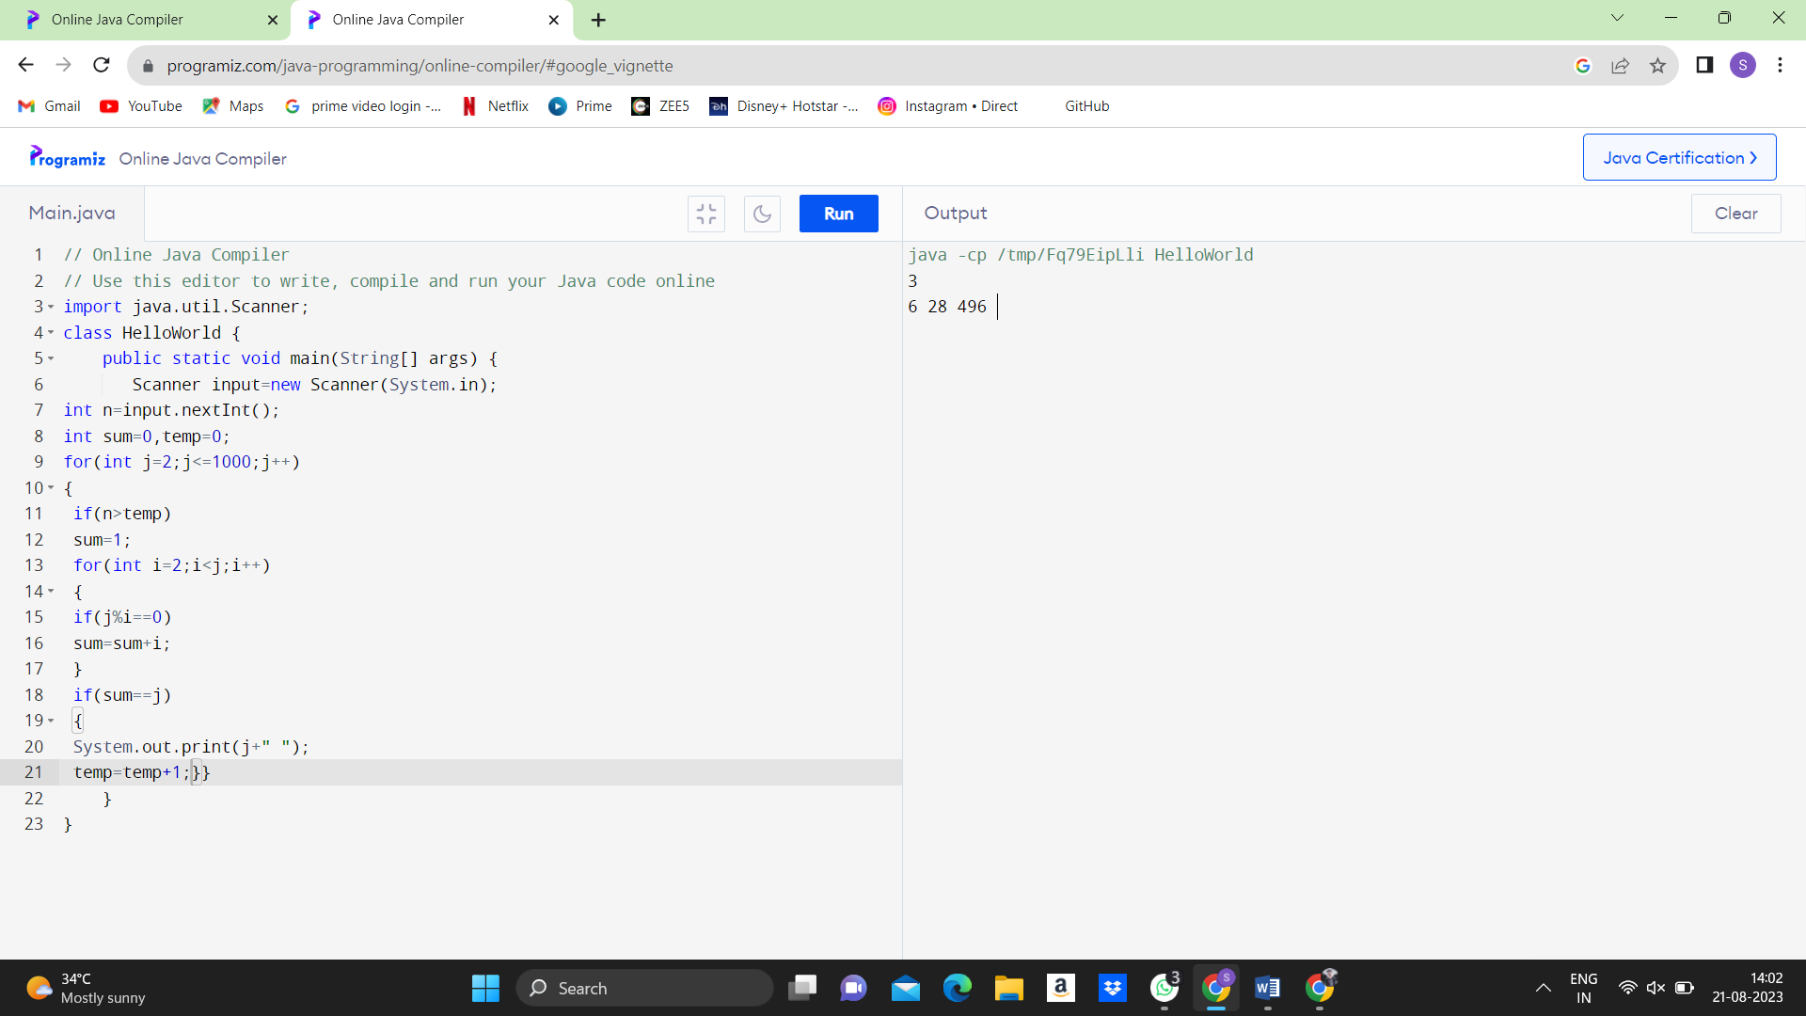

8.Write a program to enter the marks of a student in four subjects. Then calculate the total and aggregate, display the grade obtained by the student. If the student scores an aggregate greater than 75%, then the grade is Distinction. If aggregate is 60>= and <75, then the grade is First Division. If aggregate is 50 >= and <60, then the grade is Second Division. If aggregate is 40>= and <50, then the grade is Third Division. Else the grade is Fail.

Sample Input & Output:

Enter the marks in python: 90

Enter the marks in c programming: 91

Enter the marks in Mathematics: 92

Enter the marks in Physics: 93

Total= 366

Aggregate = 91.5

DISTINCTION

Test cases:

1. 18, 76,93,65
2. 73,78,79,75
3. 98,106,120,95
4. 96,73, -85,95
5. 78,59.8,76,79

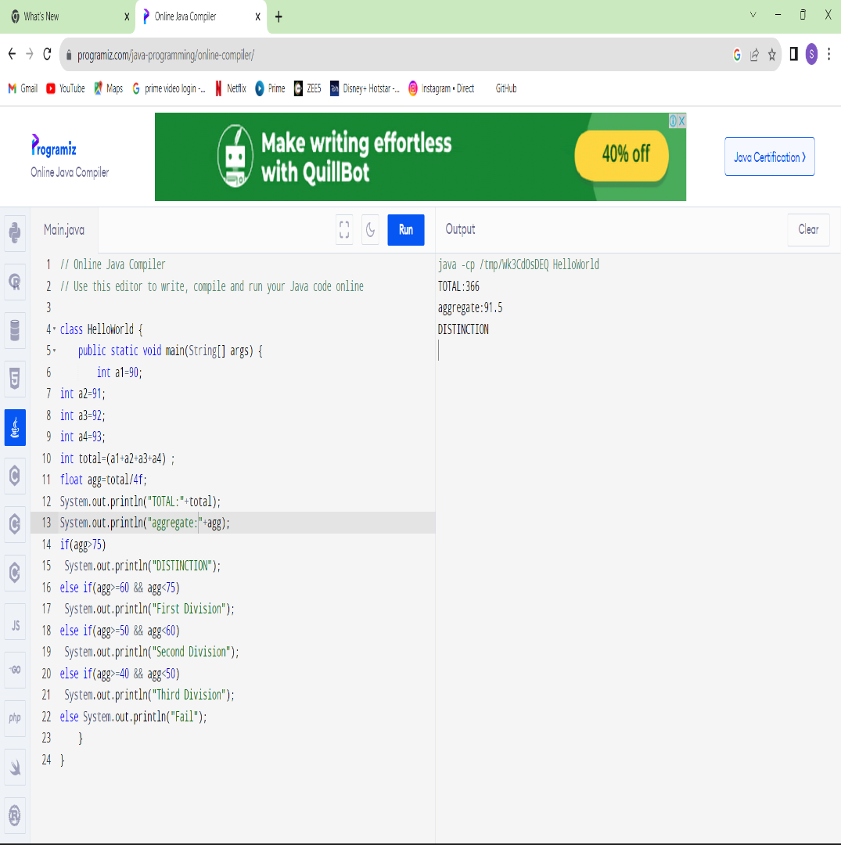

9.Write a program to read the numbers until -1 is encountered. Find the average of positive numbers and negative numbers entered by user.

Sample Input:

Enter -1 to exit…

Enter the number: 7

Enter the number: -2

Enter the number: 9

Enter the number: -8

Enter the number: -6

Enter the number: -4

Enter the number: 10

Enter the number: -1

Sample Output:

The average of negative numbers is: -5.0

The average of positive numbers is : 8.66666667

Test cases:

1. -1,43, -87, -29, 1, -9
2. 73, 7-6,2,10,28,-1
3. -5, -9, -46,2,5,0
4. 9, 11, -5, 6, 0,-1
5. -1,-1,-1,-1,-1

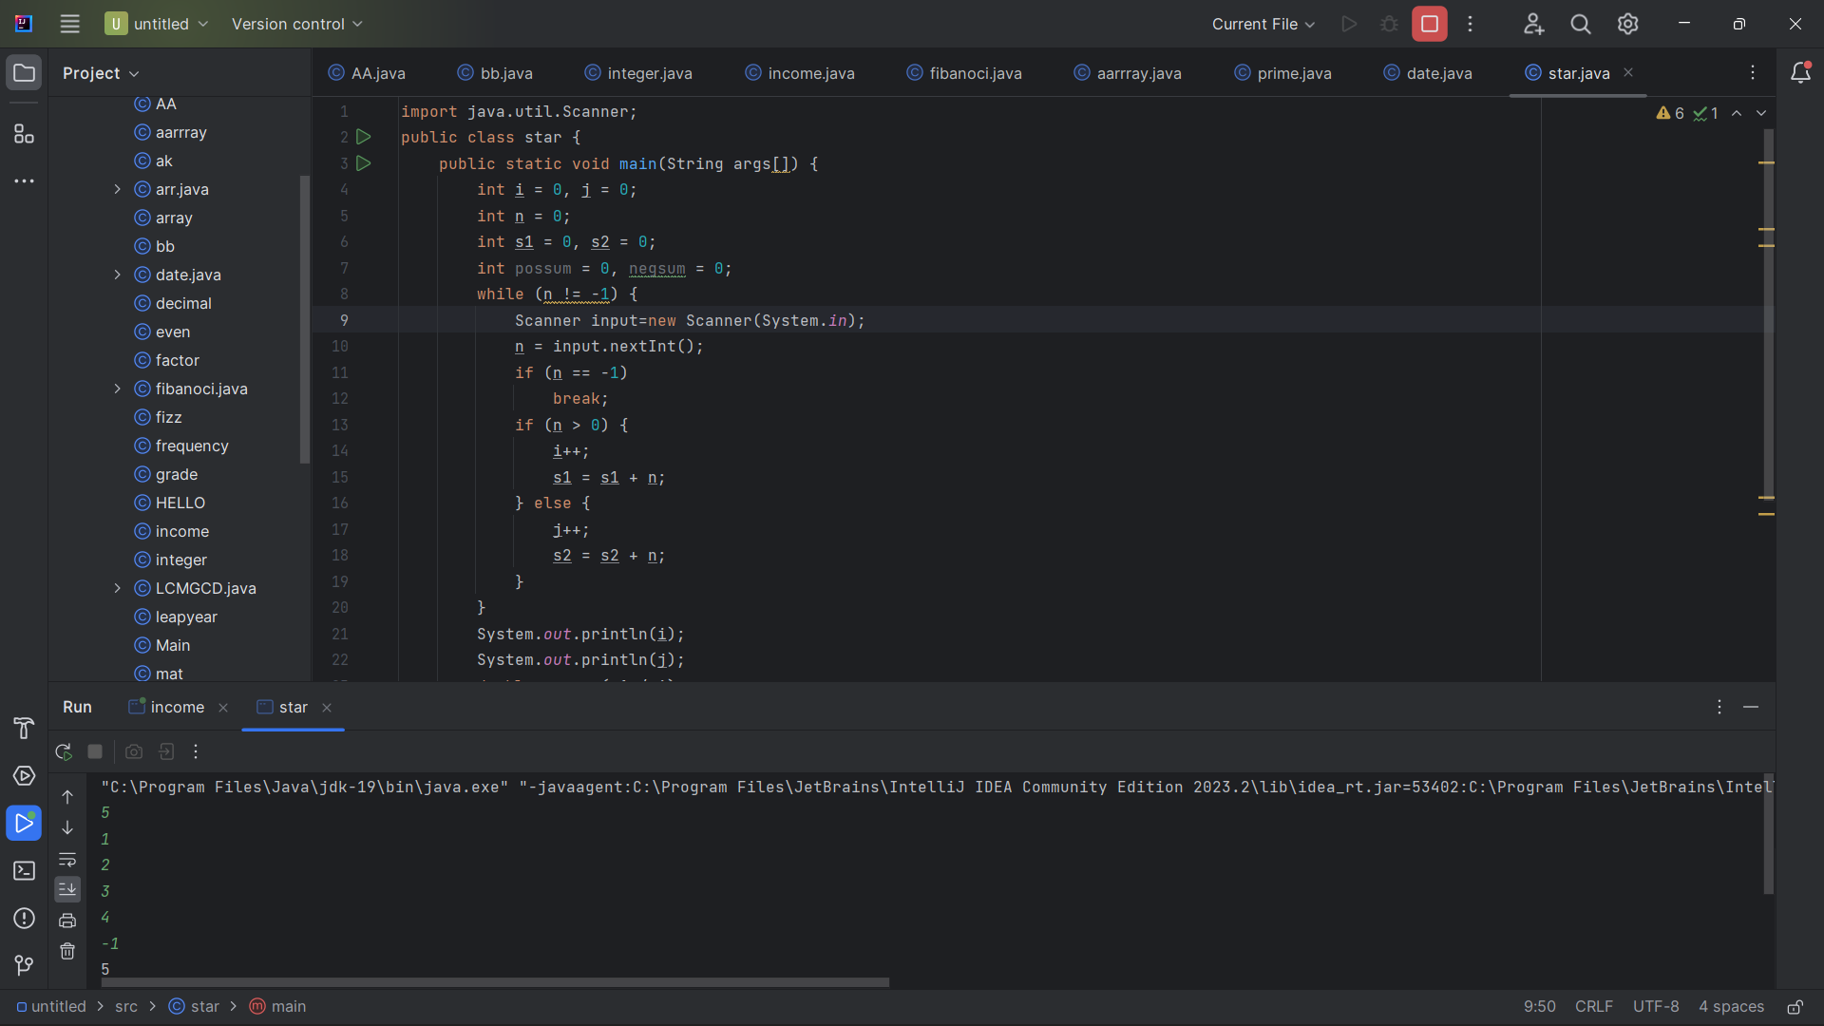

10.Write a program to read a character until a **\*** is encountered. Also count the number of uppercase, lowercase, and numbers entered by the users.

Sample Input:

Enter * to exit…

Enter any character: W

Enter any character: d

Enter any character: A

Enter any character: G

Enter any character: g

Enter any character: H

Enter any character: *

Sample Output:

Total count of lower case:2

Total count of upper case:4

Total count of numbers =0

Test cases:

1. 1,7,6,9,5
2. S, Q, l, K,7, j, M
3. M, j, L, &, @, G
4. D, K, I, 6, L, *
5. *, K, A, e, 1, 8, %, *

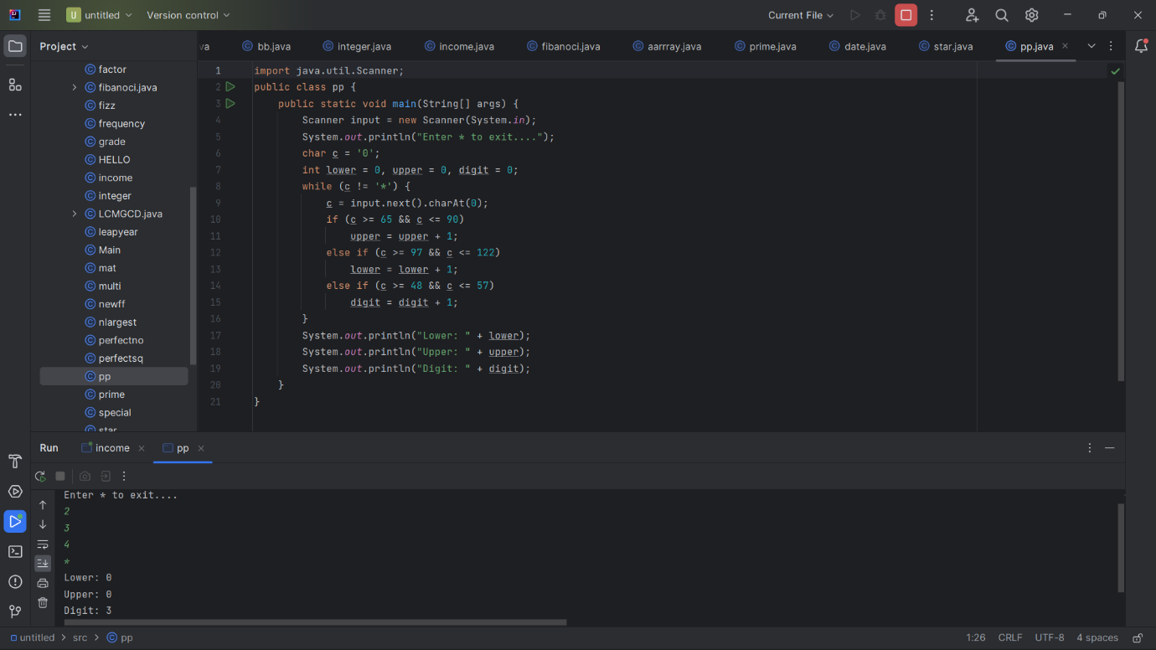

11.Write a program to calculate the factorial of number using recursive function.

Sample Input & Output:

Enter the value of n: 6

Sample Input & Output:

The factorial of 6 is: 720

Test cases:

1. N = 0
2. N = -5
3. N = 1
4. N = M
5. N = %

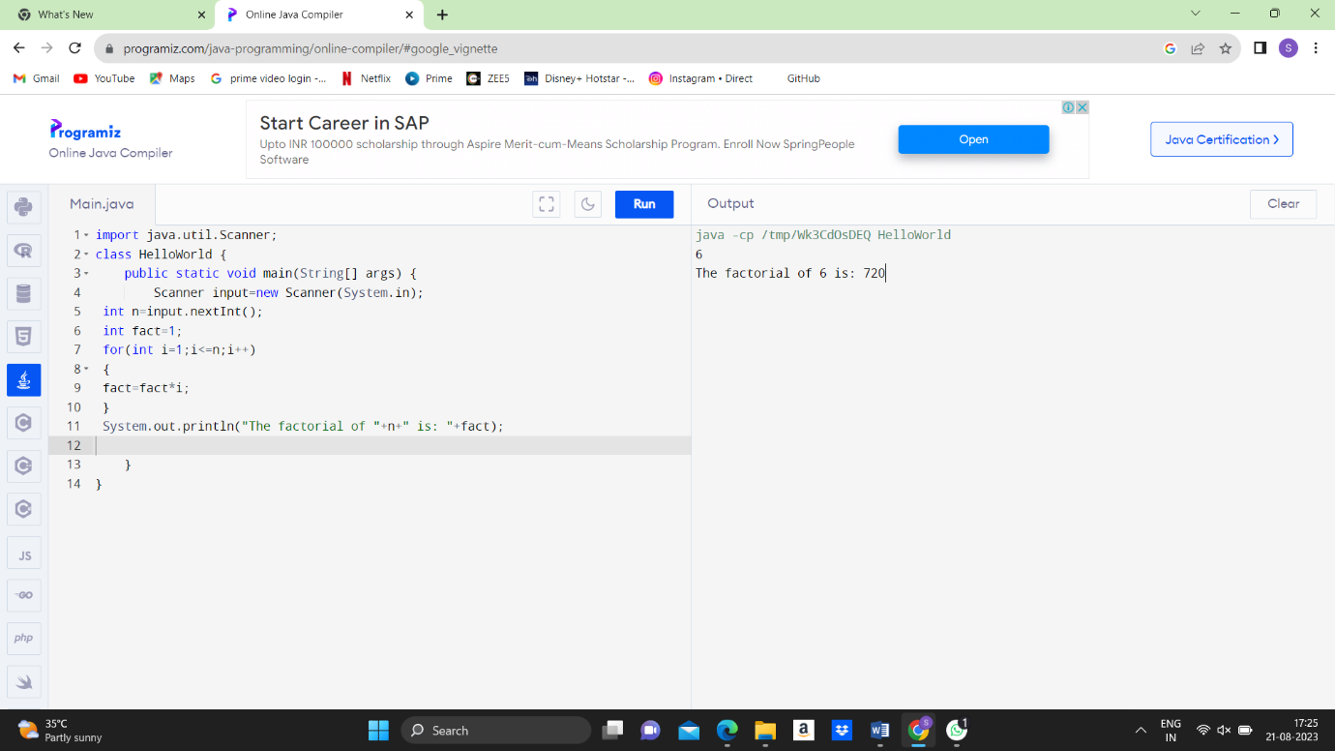

12.Write a Program to Find the Nth Largest Number in a array.

Sample Input:

List : {14, 67, 48, 23, 5, 62}

N = 4

Sample Output:

4th Largest number: 23

Test cases:

1. N = 0
2. N = -5
3. N = 1
4. N = M
5. N = %

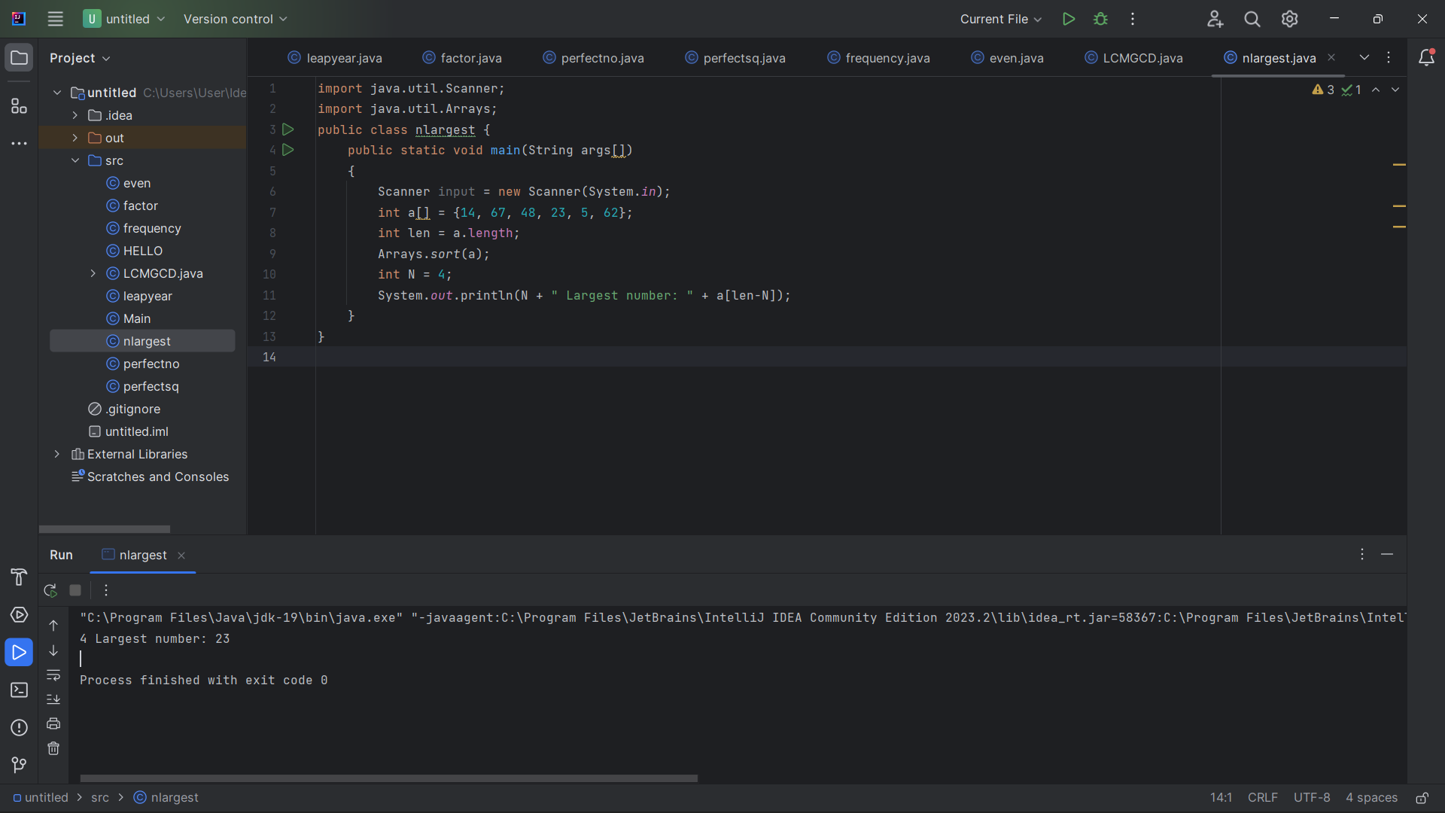

13.Write a program to convert the Binary to Decimal, Octal

Sample Input:

Given Number: 1101

Sample Output:

Decimal Number: 13

Octal:15

Test cases:

1. 211
2. 11011
3. 22122
4. 111011.011
5. 1010.0101

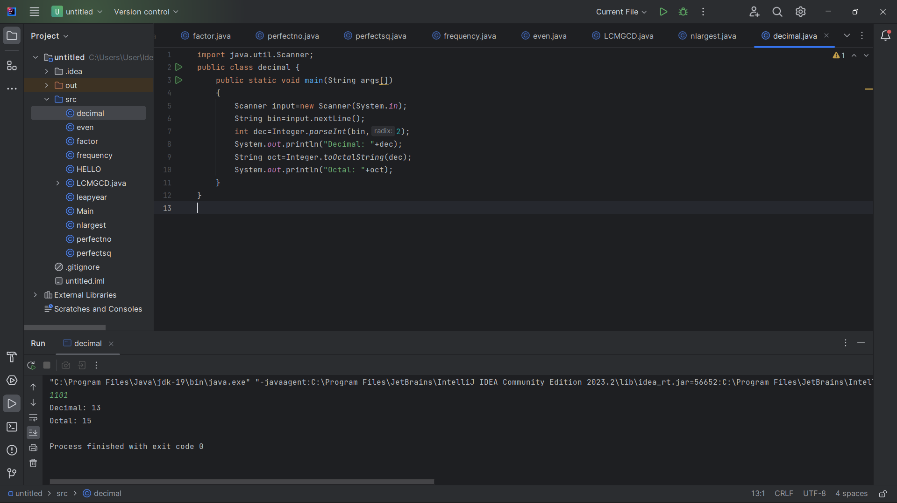

14.Write a program to find the number of special characters in the given statement

Sample Input:

Given statement: Modi Birthday @ September 17, #&$% is the wishes code for him.

Sample Output:

Number of special Characters: 5

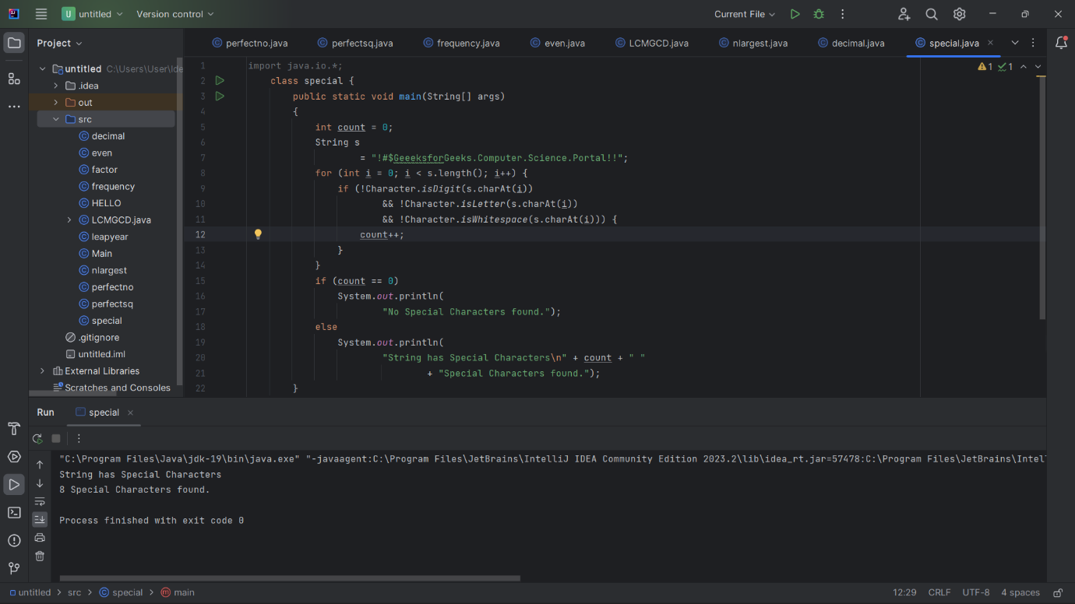

15.Write a Program to Remove the Duplicate Items from a array.

Sample Input:

Enter the number of elements in array:7

Enter element1:10

Enter element2:20

Enter element3:20

Enter element4:30

Enter element5:40

Enter element6:40

Enter element7:50

Sample Output:

Non-duplicate items:

[10, 20, 30, 40, 50]

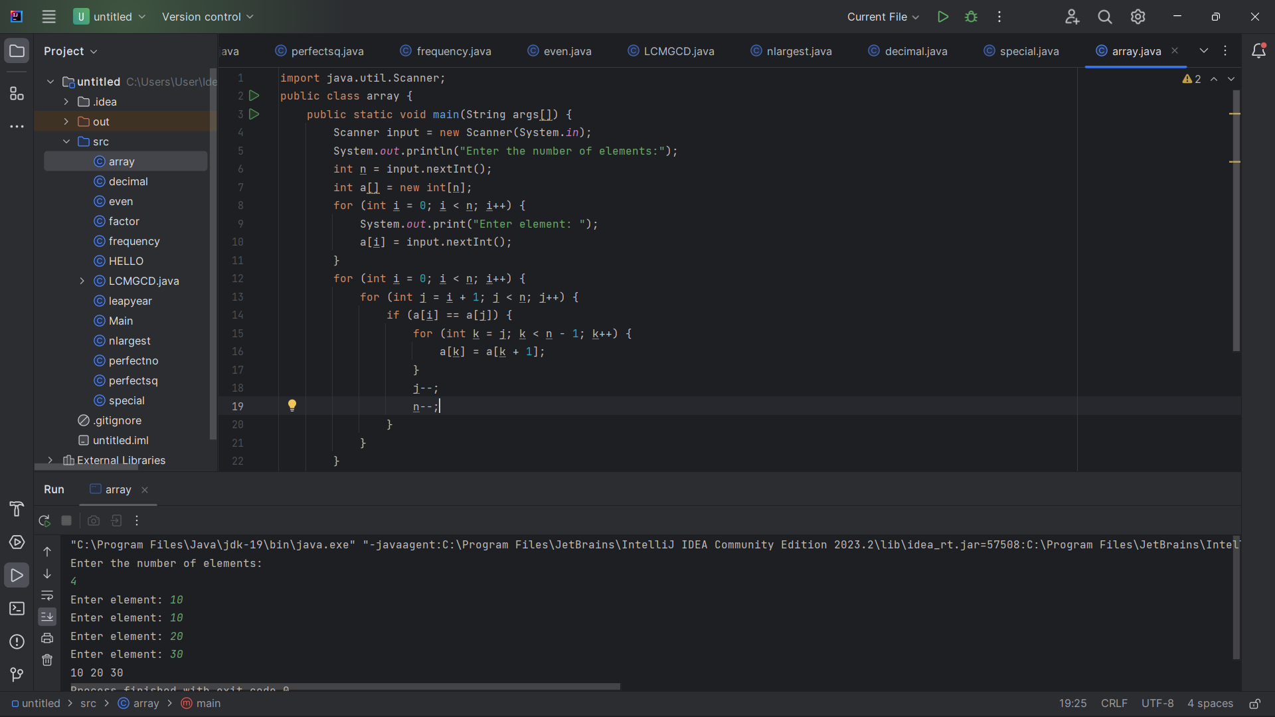

16.Bank is a class that provides method to get the rate of interest. But, rate of interest may differ according to banks. For example, SBI, ICICI and AXIS banks are providing 8.4%, 7.3% and 9.7% rate of interest. Write a Java program for above scenario.

Sample Input SBI, 8.4

Sample Output

Test case

1. SBI, 8.3
2. ICICI, 7.3
3. AXIS, 9.7
4. SBI, 8.6
5. AXIX, 7.6

class Bank  
 {  
 float getROI()  
 {  
 return 0;  
 }  
 }  
 class SBI extends Bank  
 {  
 float getROI()  
 {  
 return 8.4f;  
 }  
 }  
 class ICICI extends Bank  
 {  
 float getROI()  
 {  
 return 8.4f;  
 }  
 }  
 class AXIS extends Bank  
 {  
 float getROI()  
 {  
 return 8.4f;  
 }  
 }  
 public class arr {  
 public static void main(String[] args) {  
 Bank b;  
 b = new SBI();  
 System.*out*.println("SBI, " + b.getROI());  
}}

17.Bring out the situation in which member names of a subclass hide members by the same name in the super class. How it can be resolved? Write Suitable code in Java and

Implement above scenario with the Parametrized Constructor (accept int type parameter) of the Super Class can be called from Sub Class Using super () and display the input values provided.

Sample Input : 100, 200

Sample Output : 100, 200

Test Cases

1. 10, 20
2. -20, -30
3. 0, 0
4. EIGHT FIVE
5. 10.57, 12.58

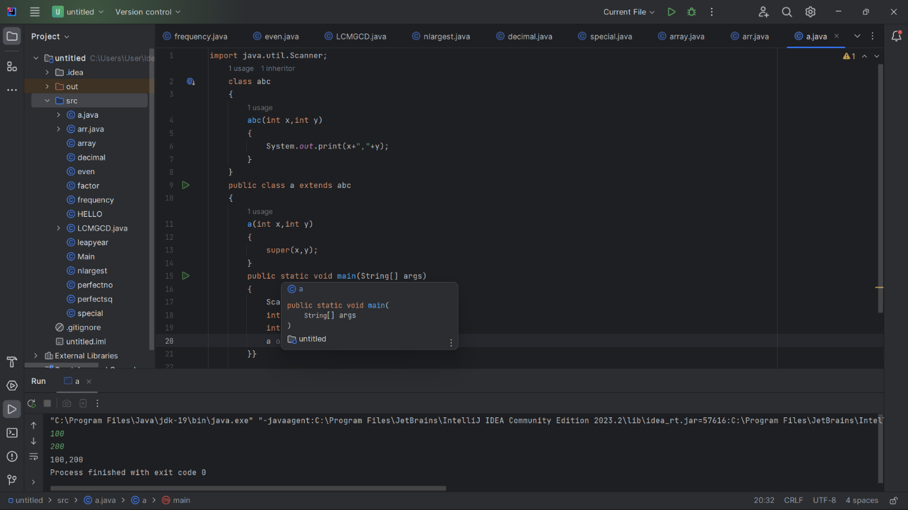

18.Display Multiplication table for 5 and 10 using various stages of life cycle of the thread by generating a suitable code in Java.

Sample Input 5, 10

5 X 1 = 5

5 X 2 =10

….

10 X 1 =10

10 X 2 = 20

….

Test Cases:

1. 10, 20
2. -10, -30
3. 0, 0
4. SIX, SIX
5. 9.8, 9.6

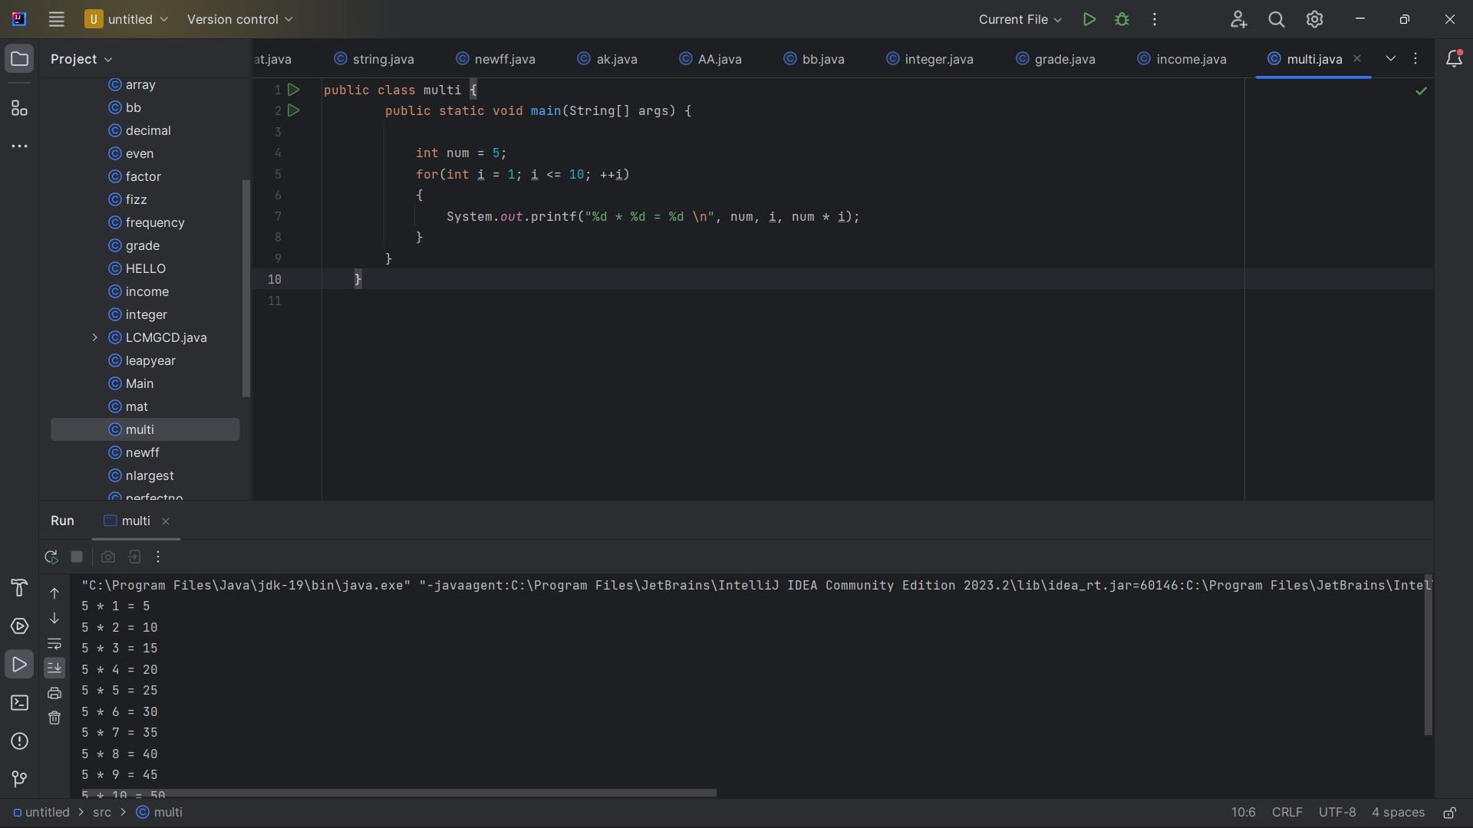

18.Using the concepts of thread with implementing Runnable interface in Java to generate Fibonacci series.

Sample Input : 5

Sample Output : 0 1 1 2 3 …..

Test Cases

1. 7
2. -10
3. 0
4. EIGHT FIVE
5. 12.65

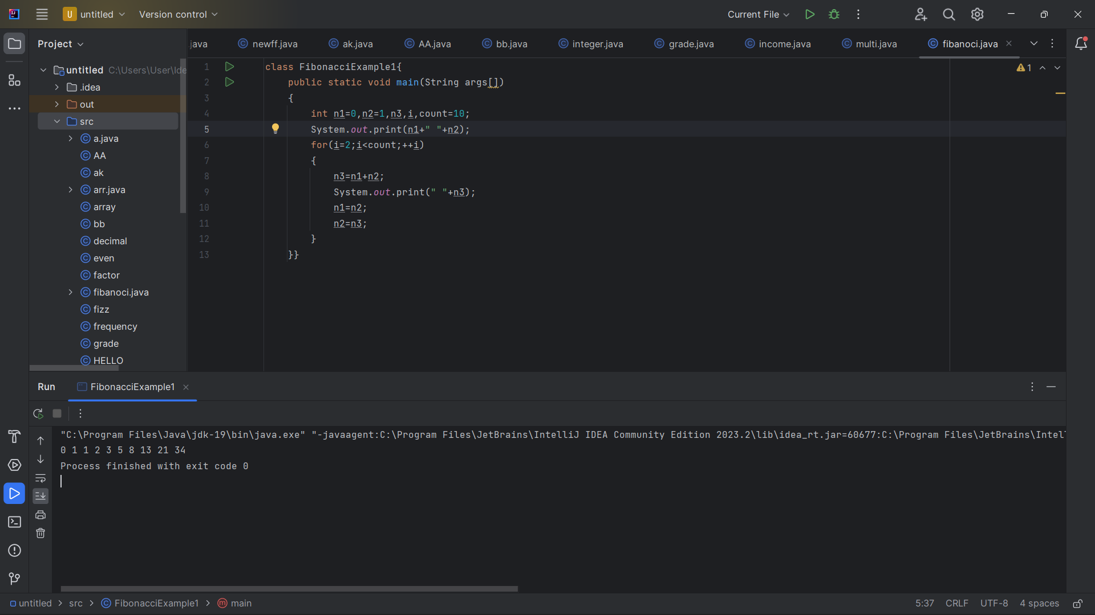

19.Generate a Java code to find the sum of N numbers using array and throw ArrayIndexOutOfBoundsException when the loop variable beyond the size N.

Sample Input : 5

1 2 3 4 5

Sample Output : 15

Test Cases

1. 4, 10
2. -10
3. 0
4. EIGHT SEVEN
5. 12.68

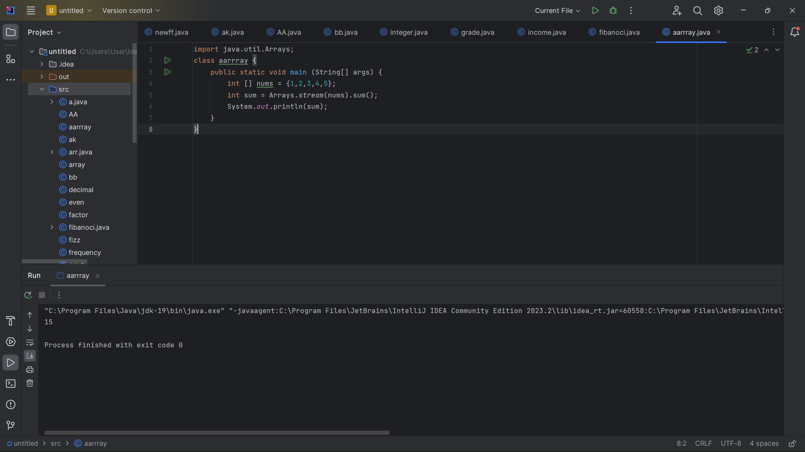

20.Using the concepts of thread with implementing Runnable interface in Java to find whether a given number is prime or not.

Sample Input : 5

Sample Output : 5 is Prime

Sample Output : 15

Test Cases

1. 4
2. -10
3. 0
4. EIGHT SEVEN
5. 11.48

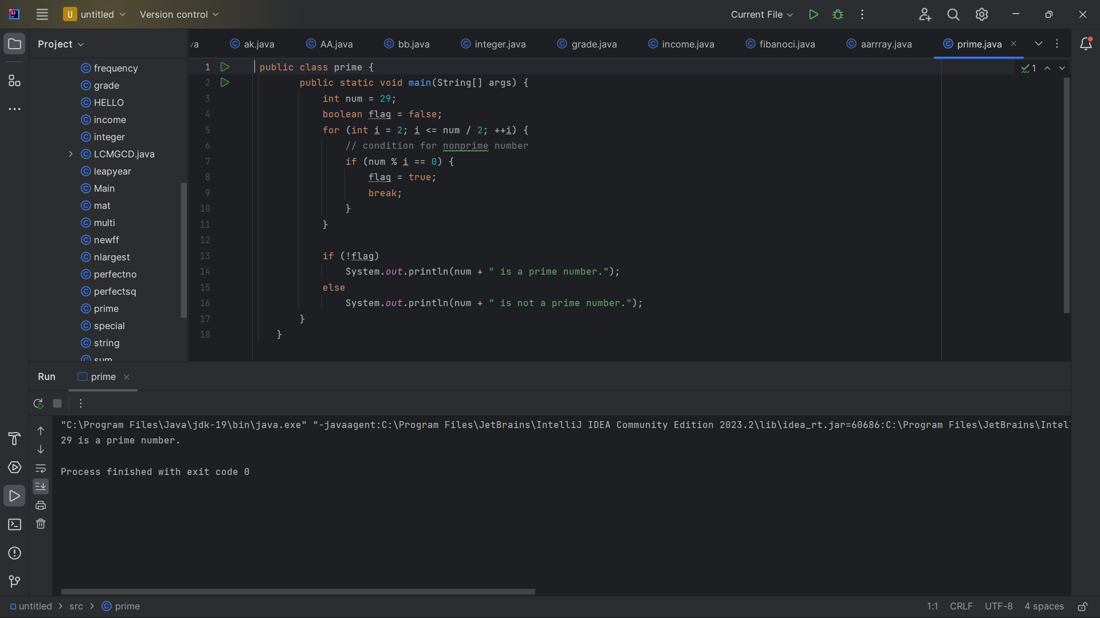

**HARD PROGRAMS (10)**

1.Create Customer class with deposit() and withdraw() as synchronized methods. Declare AccountNo, AccName and Balance as Instance Variables inside the class. From the main class, Input the amount for withdraw() operation and if requested amount is not available in existing Balance amount, withdraw() method should be temporarily suspended using wait() method until deposit() method receives the input for amount, to be added in the existing Balance amount and then withdraw() would be completed in a successful manner. Develop the above scenario using Synchronization and Inter-Thread Communication.

Note : existing Bank balance amount 10000

Sample Input : 12000, 3000

Sample Output : Withdraw operation success, balance amount 1000

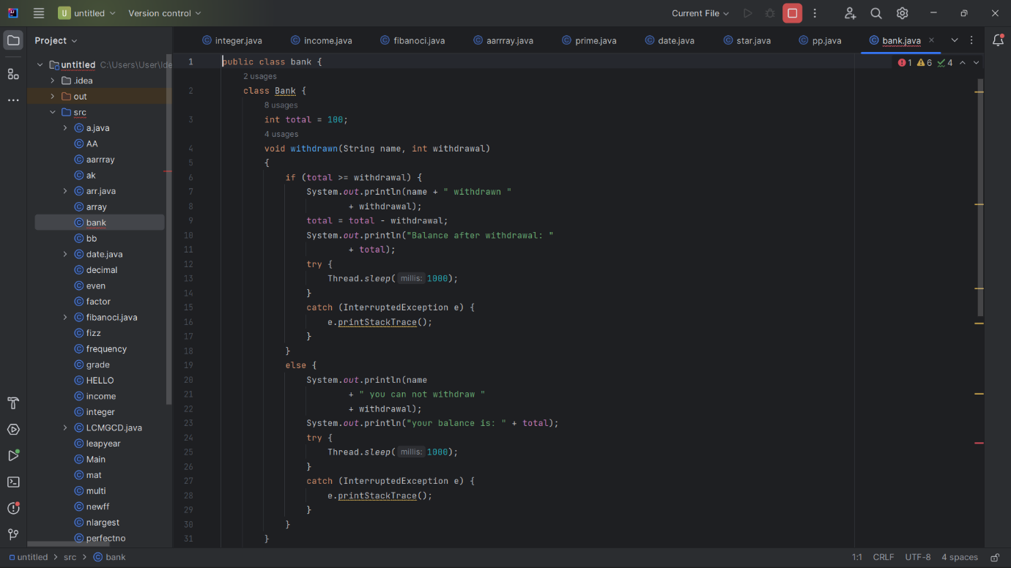

2.Given an integer n, return a string array answer (1-indexed) where:

answer[i] == "FizzBuzz" if i is divisible by 3 and 5.

answer[i] == "Fizz" if i is divisible by 3.

answer[i] == "Buzz" if i is divisible by 5.

answer[i] == i (as a string) if none of the above conditions are **true.**

**Example 1:**

Input: n = 3

Output: ["1","2","Fizz"]

**Test Case**

|  |  |
| --- | --- |
| **Test Case** | **Inputs** |
|  | n = 5 |
|  | n = 10 |
|  | n = 12 |
|  | n = 18 |
|  | n = 20 |

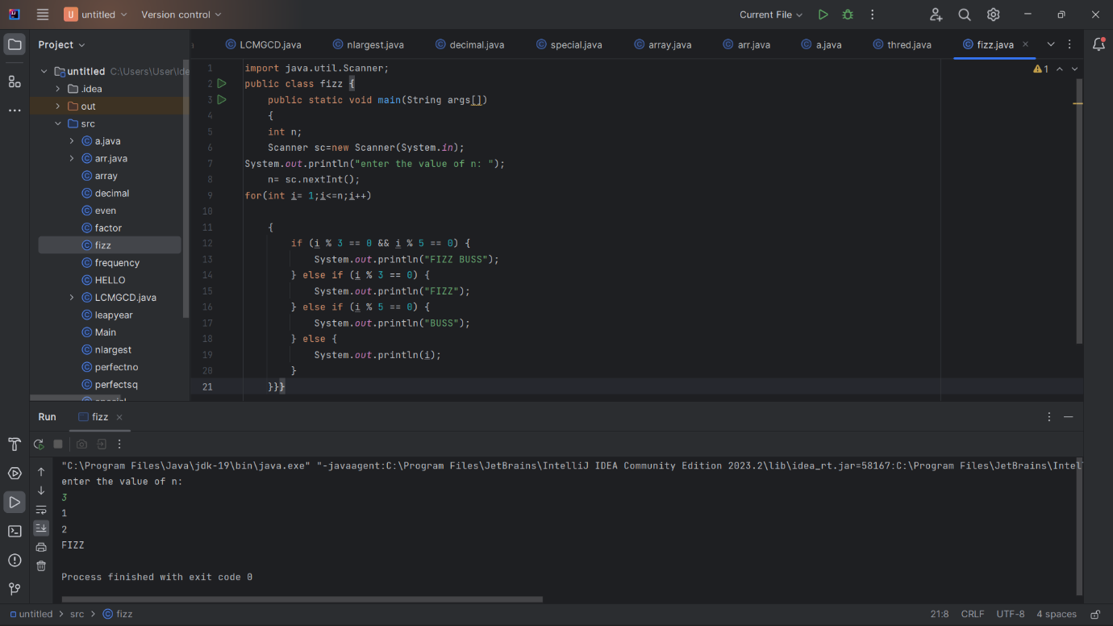

**3.**Write a Java program to find the common elements in two array of Positive integer

Sample Input:

[1, 2, 3, 4]

[2, 4, 5, 6, 7]

Expected output: [2, 4]

**Test Case**

|  |  |  |
| --- | --- | --- |
| **Test Case** | **Inputs-1** | **Inputs-2** |
|  | [1, 2, 3, 4] | [4,5,6,7,8] |
|  | [a, b, c, d] | [a, b, c, d] |
|  | [1, -2, 3, 4] | [1,-2,5,7,8] |
|  | [@, #, 34, 45] | [@,#,%,$,] |
|  | [45,78,56,89] | [92,34,56,-78,-90] |

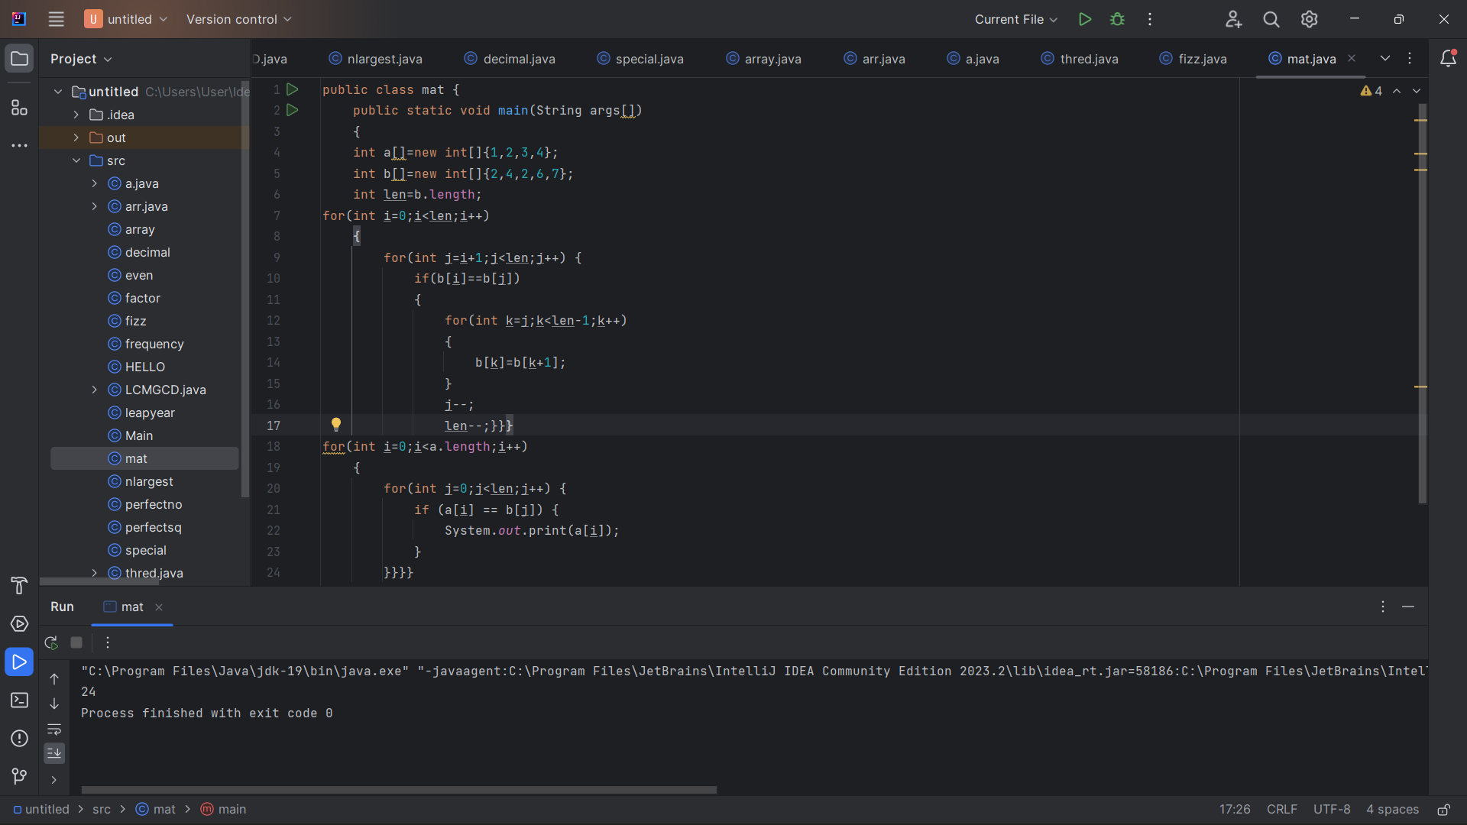

4.Given a string s consisting of words and spaces, return the length of the **last** word in the string. A **word** is a maximal substring consisting of non-space characters only. There will be at least one word, consists of only English letters and spaces ' '.

**Example 1:**

**Input:** s = "Hello World"

**Output:** 5

**Explanation:** The last word is "World" with length 5.

**Test Case**

|  |  |
| --- | --- |
| **Test Case** | **Inputs-1** |
|  | Maximal Substring Consisting |
|  | **lea@st one wor2d** |
|  | 1254 98076 |
|  | & * ( ) % # $ |
|  | letters and spaces |

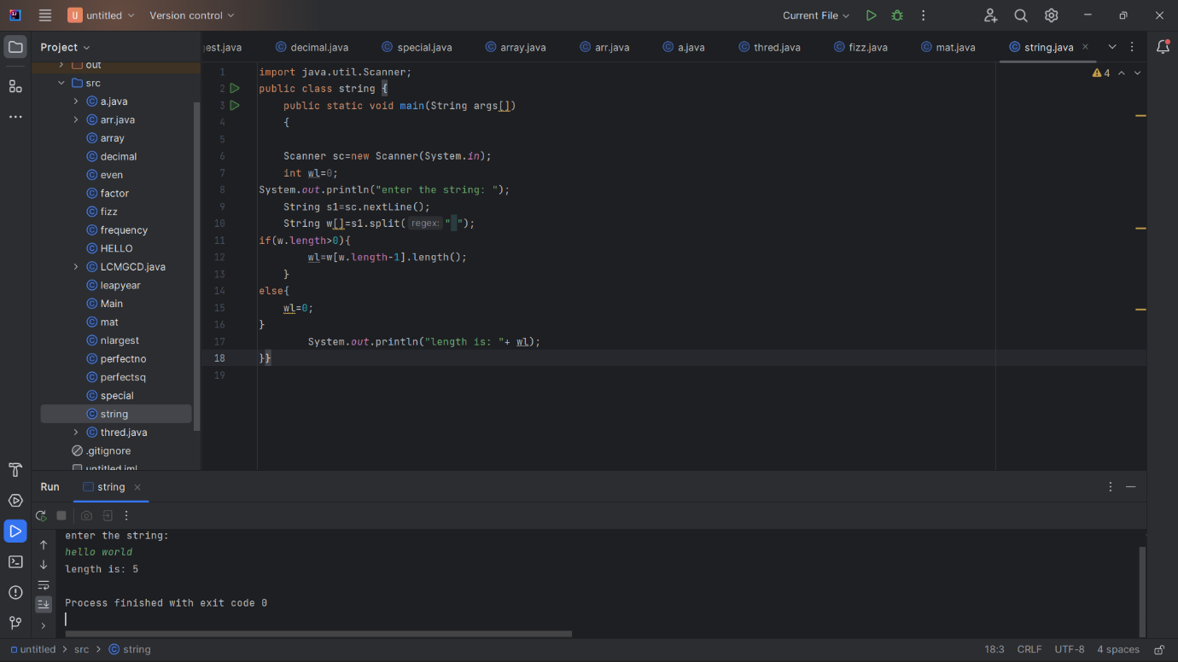

5.Roman numerals are represented by seven different symbols: I, V, X, L, C, D and M.

SymbolValue

I 1

V 5

X 10

L 50

C 100

D 500

M 1000

For example, 2 is written as II in Roman numeral, just two ones added together. 12 is written as XII, which is simply X + II. The number 27 is written as XXVII, which is XX + V + II.

Roman numerals are usually written largest to smallest from left to right. However, the numeral for four is not IIII. Instead, the number four is written as IV. Because the one is before the five we subtract it making four. The same principle applies to the number nine, which is written as IX. There are six instances where subtraction is used:

* I can be placed before V (5) and X (10) to make 4 and 9.
* X can be placed before L (50) and C (100) to make 40 and 90.
* C can be placed before D (500) and M (1000) to make 400 and 900. Given a roman numeral, convert it to an integer.

**Example:**

**Input:** s = "III"

**Output:** 3

|  |  |
| --- | --- |
| **Test Case** | **Inputs** |
|  | LVIII |
|  | MCMXCI |
|  | V |
|  | LZAII |
|  | MCCDTIV |

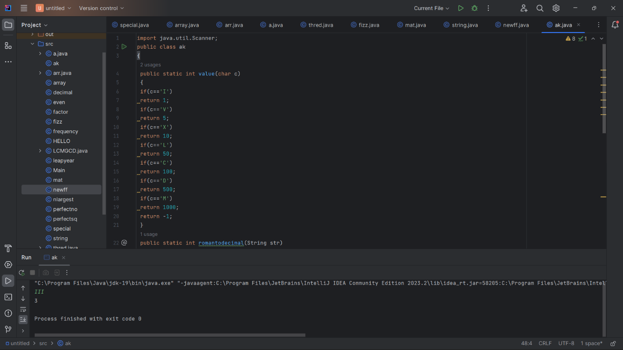

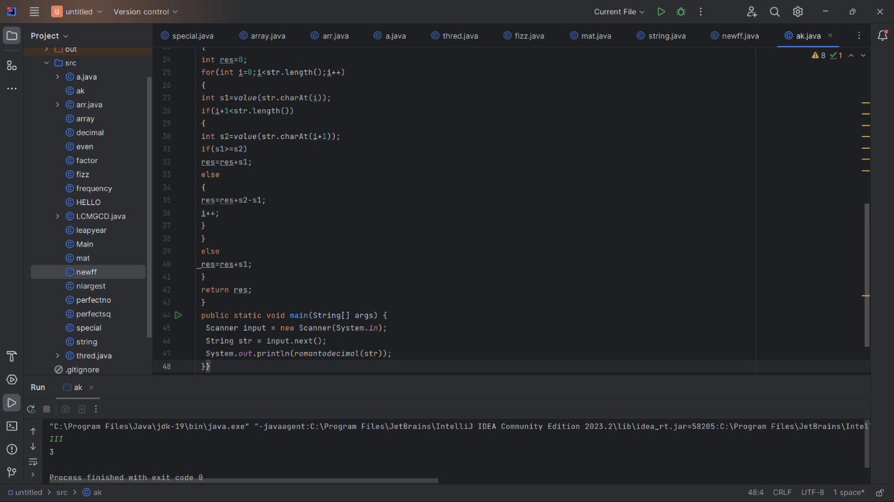

6.Given two strings ransomNote and magazine, return true if ransomNote can be constructed by using the letters from magazine and false otherwise. Each letter in magazine can only be used once in ransomNote.

**Example 1:**

Input: ransomNote = "a", magazine = "b"

Output: false

**Test Case**

|  |  |
| --- | --- |
| **Test Case** | **Inputs** |
|  | ransomNote = "aa", magazine = "ab" |
|  | ransomNote = "aa", magazine = "aab" |
|  | ransomNote = "abc", magazine = "abc" |
|  | ransomNote = "good", magazine = "better" |
|  | ransomNote = "xyz", magazine = "123" |

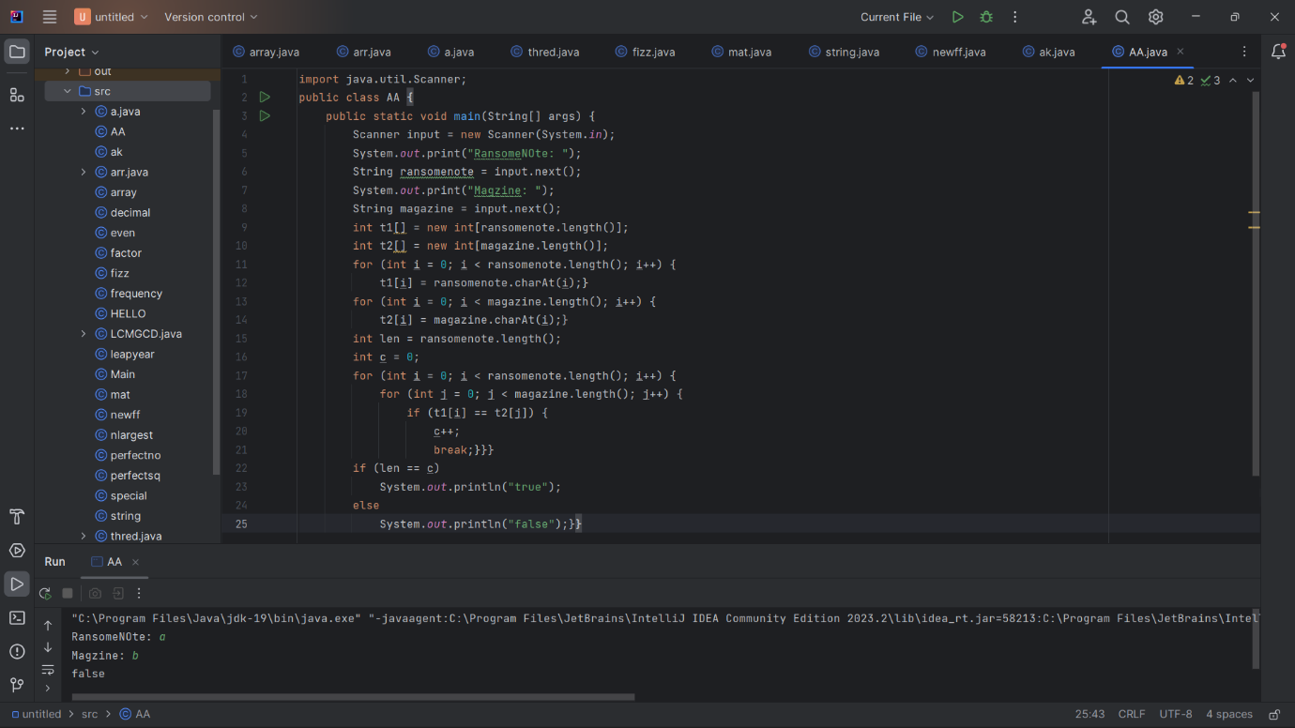

7.You are given an m x n binary matrix mat of 1's (representing soldiers) and 0's (representing civilians). The soldiers are positioned in front of the civilians. That is, all the 1's will appear to the left of all the 0's in each row.

A row i is weaker than a row j if one of the following is true:

The number of soldiers in row i is less than the number of soldiers in row j.

Both rows have the same number of soldiers and i< j. Return the indices of the k weakest rows in the matrix ordered from weakest to strongest.

**Example 1:**

Input: mat =

[[1,1,0,0,0],

[1,1,1,1,0],

[1,0,0,0,0],

[1,1,0,0,0],

[1,1,1,1,1]],

k = 3

Output: [2,0,3]

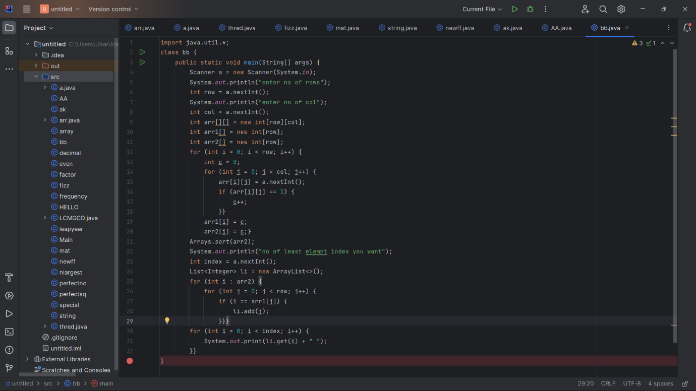

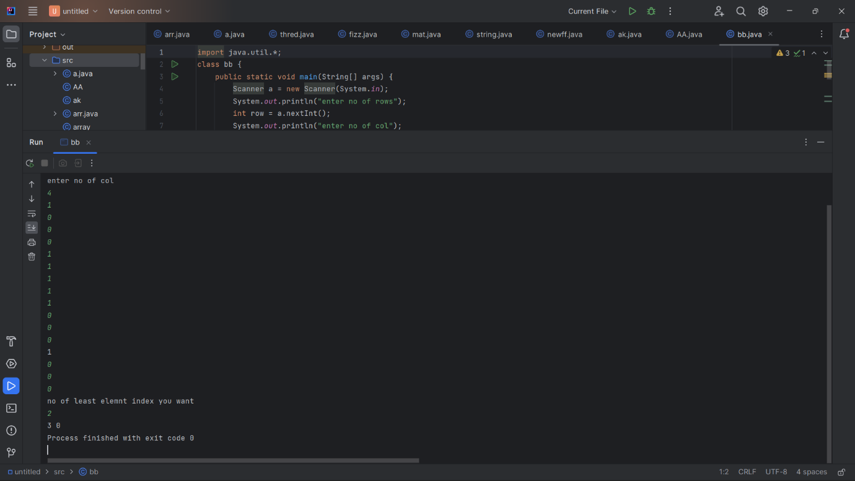

8.Given an integer num, return the number of steps to reduce it to zero. In one step, if the current number is even, you have to divide it by 2, otherwise, you have to subtract 1 from it.

**Example 1:**

Input: num = 14

Output: 6

Explanation:

Step 1) 14 is even; divide by 2 and obtain 7.

Step 2) 7 is odd; subtract 1 and obtain 6.

Step 3) 6 is even; divide by 2 and obtain 3.

Step 4) 3 is odd; subtract 1 and obtain 2.

Step 5) 2 is even; divide by 2 and obtain 1.

Step 6) 1 is odd; subtract 1 and obtain 0.

**Test Case**

|  |  |
| --- | --- |
| **Test Case** | **Inputs** |
|  | n = 5 |
|  | n = 10 |
|  | n = 12 |
|  | n = 18 |
|  | n = 20 |

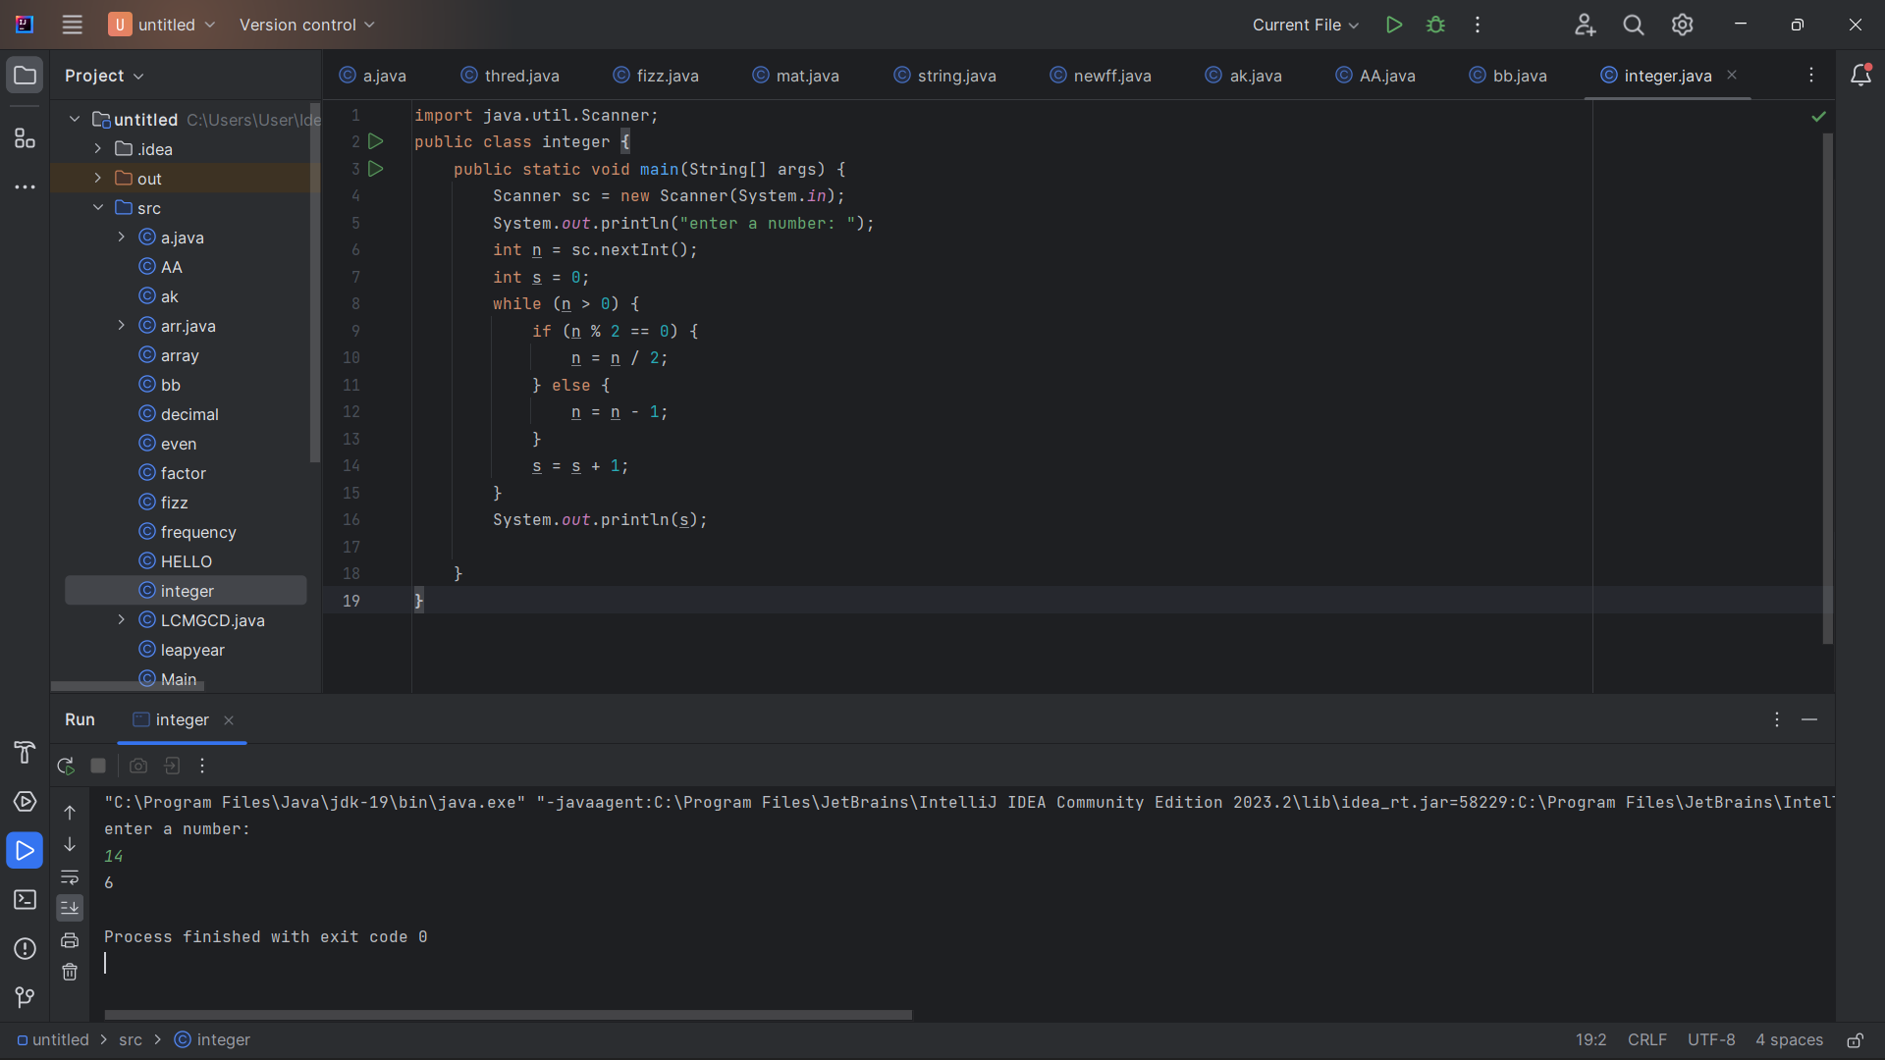

9.Develop a programme that uses Multiple Inheritance concepts to compute a student's grades in six subjects. The total and aggregate are then calculated, and the student's grade is displayed. If the student achieves an aggregate of more than 75%, the grade is Distinction. If the aggregate is between 60 and 75, the grade is First Division. If the aggregate is between 50 and 60, the grade is Second Division. If the aggregate is between 40 and 50, the grade is Third Division. Otherwise, the grade is FAIL.

Sample Input & Output:

Enter the marks in python: 90

Enter the marks in c programming: 91

Enter the marks in Mathematics: 92

Enter the marks in Physics: 93

Enter the marks in Chemistry: 92

Enter the marks in Professional Ethics: 93

Total= 551

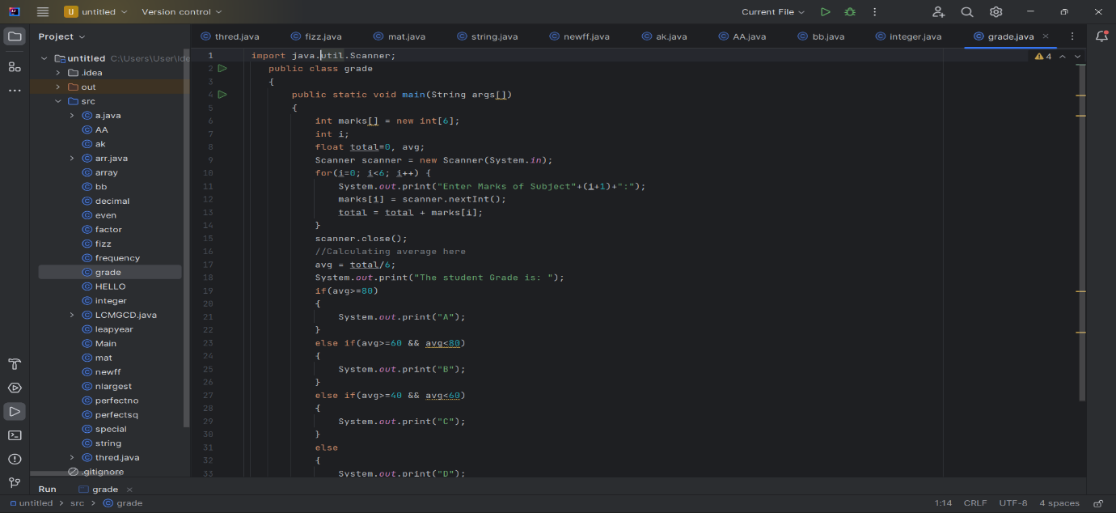

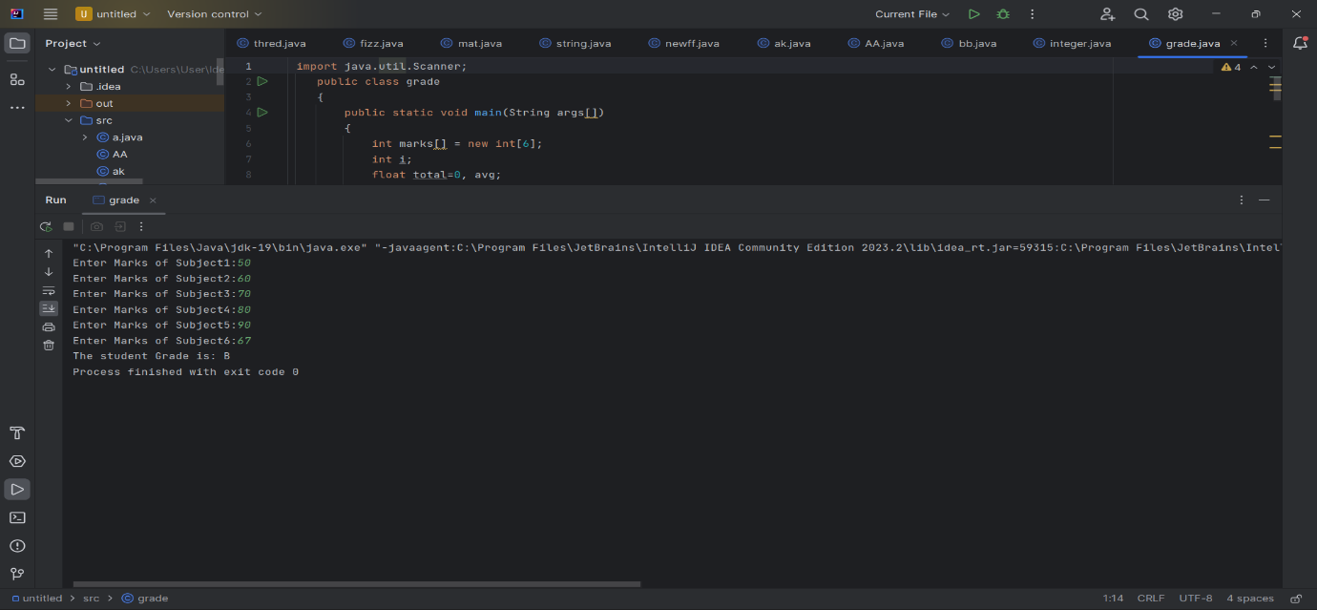

10.Write a program to calculate tax given the following conditions:

* + 1. If income is less than or equal to 2,50,000 then no tax
    2. If taxable income is 2,50,001 – 5,00,000 the charge 10% tax
    3. If taxable income is 5,00,001 – 10,00,000 the charge 20% tax
    4. If taxable income is above 10,00,001 then charge 30% tax

**Sample Input:**

Enter the income: 600000

**Sample Output:**

Taxable Income: 350000

Tax= 35000

**Test Case**

|  |  |
| --- | --- |
| **Test Case** | **Inputs** |
|  | 400700 |
|  | 2789239 |
|  | 150000 |
|  | 00000 |
|  | -125486 |

